GALAPAGOS ISLANDS
ALYA CATAMARAN-ITINERARY A
5 DAYS AND 4 NIGHTS
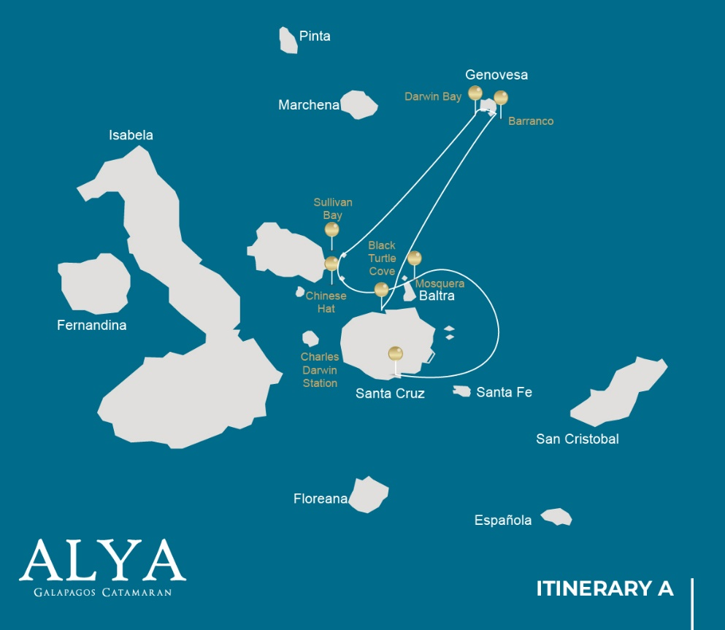

Itinerary A-5 days
Day 1 | AM: Baltra airport  PM: Santa Cruz: Black Turtle Cove
Day 2 | AM: Genovesa: Darwin Bay  PM: Genovesa: Barranco
Day 3 | AM: Santiago: Sullivan Bay  PM: Bartolome
Day 4 | AM: Santiago: Chinese Hat  PM: Mosquera
Day 5 | AM: Santa Cruz: Charles Darwin  PM: Baltra airport

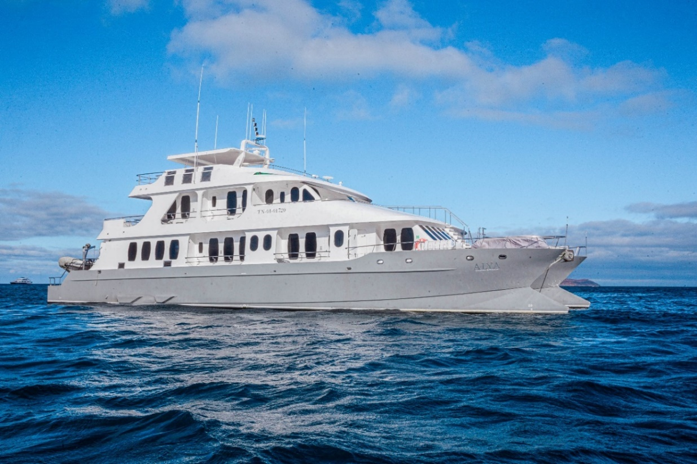
DAY 01: ALYA CATAMARAN: BALTRA AIRPORT AND BLACK TURTLE COVE

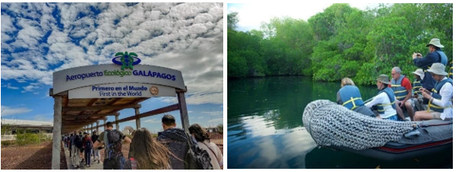

AM: BALTRA AIRPORT
Departure to the Galapagos Islands, arrival at Baltra airport, where our naturalist guide of the National Park will be waiting for you.

PM: BLACK TURTLE COVE
Black Turtle Cove gets its name from the abundance of green see turtles, locally known as: “tortugas negras”. There is no landing here so you will be doing a boat tour on the dinghies, exploring shallow channels and small coves surrounded by beautiful mangrove forests. Reef sharks, sea turtles and several species rays inhabit this beautiful area which is considered an important mating area for turtles and a nursery for several species of sharks. Herons, pelicans and boobies are also common here as they prey in schools of anchovies.

Accomodation: | M/C Alya
Included meals: | Lunch or Box lunch, Dinner

DAY 02: ALYA CATAMARAN: DARWIN BAY AND BARRANCO
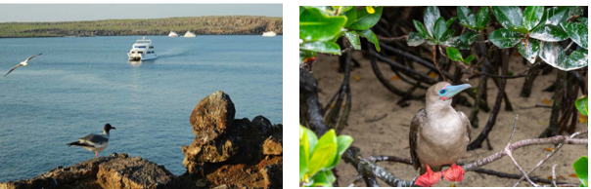

AM: DARWIN BAY
Genovesa is a favorite island for birdwatchers as it is home for very large colonies of seabirds. From the minute you set foot at the beach you will be amazed by the noise of hundreds of boobies, gulls and frigate birds flying over your heads, perched in the bushes or nesting on the sandy terrain. The trail is an ultimate wildlife experience as there are animals everywhere; sea lions and marine iguanas near the sea;night herons, lava & swallow-tailed gulls, Darwin finches, Galapagos doves, mockingbirds and many morespecies inland.

Snorkel: The bay offers several places to snorkel; from deep waters along the cliffs across the bay, to shallow waters by the beach. In either case, there are many fish to see and great chances of seeing sharks, rays and sea lions.

PM: EL BARRANCO
El Barranco is located in the southern part of Darwin Bay at Genovesa Island. The cliffs face the sea are made of very fragile fractured lava, making it the ideal place for storm petrel to build their colonies, whichattracts an important population of short-eared owls preying of the nesting birds. Red footed and Nazcaboobies are abundant along the trail. At the base of the cliffs you can see Galapagos fur seals resting in shaded areas, as well as several species of seabirds.

Snorkel: You can snorkel along the cliffs where there are many fish and great chances of seeing sharks, rays and sea lions.

Accomodation: | M/C Alya
Included meals: | Breakfast, Lunch, Dinner

DAY 03: ALYA CATAMARAN: SULLIVAN BAY AND BARTOLOME ISLAND

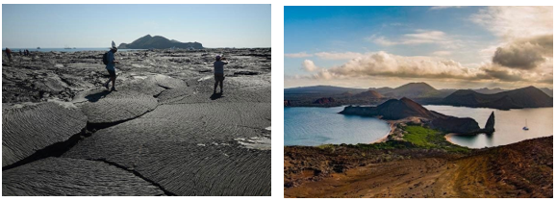

AM: SULLIVAN BAY
This hike is a journey into understanding the birth of these volcanic islands. You will walk in a very well-preserved flow of Pahoehoe lava, which will give you endless opportunities to see the delicate textures of these type of lavas which only appear in a few places throughout the world. At first sight the barren

landscape looks completely deprived of life, but look carefully for pioneer plants, lava lizards and small birds. By the shore, you can find penguins, pelicans and oystercatchers.

Snorkel: You will have the option to swim or snorkel from a coral sand beach or from the dinghies. Getting underwater is like traveling to another world: if the land is almost lifeless, the sea is teaming with life, including large schools of fish, Galapagos penguins, reef sharks, turtles and rays.

PM: BARTOLOME
Bartolome is one of the most iconic places in the Galapagos and one of the few where you can see penguins without going to the remote areas of western Isabela and Fernandina. You will get great viewsof Pinnacle Rock, located in the northern side of the island, right next to a beautiful peach-color sand beach.
The hike to the top of the island is fantastic and will offer you incredible views of lunar landscapes with scattered volcanic cones. Many islands are visible from this outlook, as well as the bay of Sullivan and thePinnacle rock.

Snorkel: You will have the option to swim or snorkel from the beach. This area holds a well- deserved reputation of being one of the best snorkeling places in the Galapagos, not only because it’s clear and calm water, but also because of the presence of penguins, which are relatively easy to find while snorkeling, along with an incredible diversity of fish, colorful invertebrates, sea lions, turtles, rays and reef sharks.

Accomodation: | M/C Alya
Included meals: | Breakfast, Lunch, Dinner

DAY 04: ALYA CATAMARAN: CHINNESE HAT AND MOSQUERA ISLET

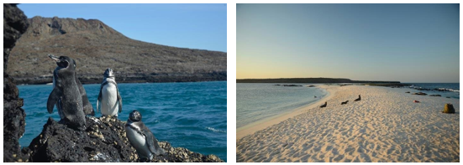

AM: CHINESE HAT
This small islet is formed by a volcanic cone with a perfect symmetrical shape. It is separated from Santiago by a narrow channel forming one of the most beautiful bays in the islands. Blue- turquoise waterand coral sand beaches surrounded by dark lava rocks gives this area a real tropical character,

which makes even more surprising finding penguins resting in the rocks. The trail goes along the shore, taking you through a small colony of sea lions.

Snorkel: When you swim in this place you will get mesmerized by the incredible colors of the fish and thesleek silhouette of reef sharks and, it is not uncommon to see a penguin darting through the water chasinganchovies like a small torpedo.

PM: MOSQUERA
Mosquera is mostly a barren sand bar with some rocky areas and scattered salt-resistant plants. You canwalk along the beach and enjoy seeing playful sea lion pups surfing the waves and having a great time inthe tide pools. Look for endemic lava gulls which are often seen flying over the beach in the search of food.

Snorkel: If the waves are not too big you can snorkel at the northern tip of the island or at one of the small beaches in the sheltered side.

Accomodation: | M/C Alya
Included meals: | Breakfast, Lunch, Dinner

DAY 05: ALYA CATAMARAN: CHARLES DARWIN STATION-FAREWALL GALAPAGOS
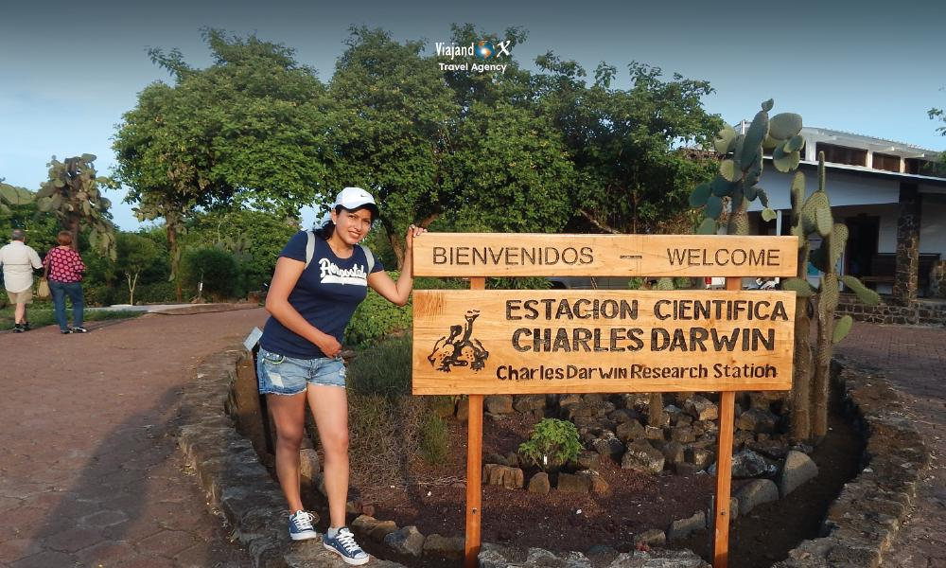

AM: CHARLES DARWIN STATION
The Charles Darwin Station is a nonprofit organization which has been working for decades together with the Galapagos National Park to preserve the biodiversity of these unique islands. During this visit you willlearn about the projects that both institutions carry together to protect the native species and eradicatethe invasive ones which are threatening the Galapagos environment. One of the most important and emblematic projects has been reproducing giant tortoises in captivity. The visit is mostly outdoors in a beautiful dry native forest with giant cactus and many other interesting native plants. It is also a fantasticplace to find several endemic Darwin finches, as well as flycatchers and mockingbirds.
Transfer to Baltra airpot and flight back to Ecuador mainland.

Accomodation: | M/C Alya
Included meals: | Breakfast

