GALAPAGOS ISLANDS
ALYA CATAMARAN-ITINERARY B
6 DAYS AND 5 NIGHTS
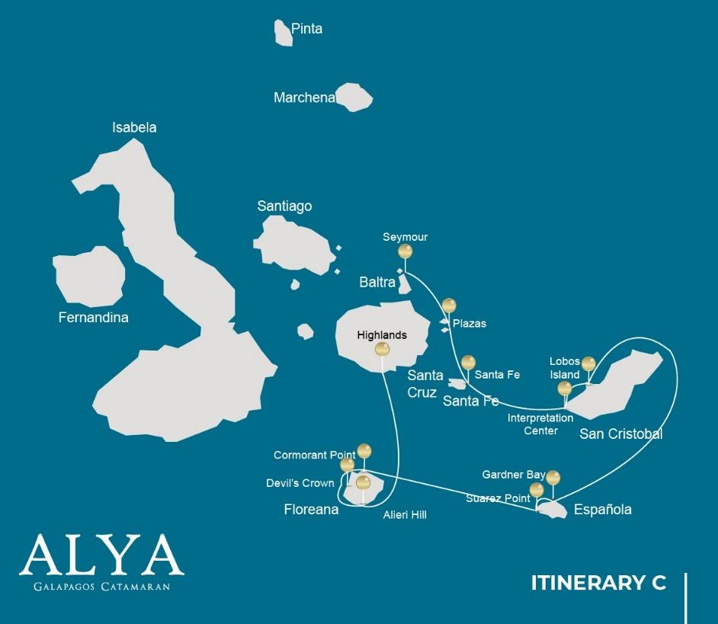

Itinerary C- 6 days
Day 1 | AM: Baltra airport  PM: Seymour
Day 2 | AM: Plazas  PM: Santa Fe
Day 3 | AM:San Cristobal: Interpretation Center/Kicker Rock  PM: San Cristobal: Lobos Island
Day 4 | AM: Española: Gardner Bay  PM: Española: Suarez point
Day 5 | AM: Floreana: Cormorant Point/Devil´s Crown  PM: Floreana: Alieri Hill
Day 6 | AM: Santa Cruz: Highlands  PM: Baltra airport

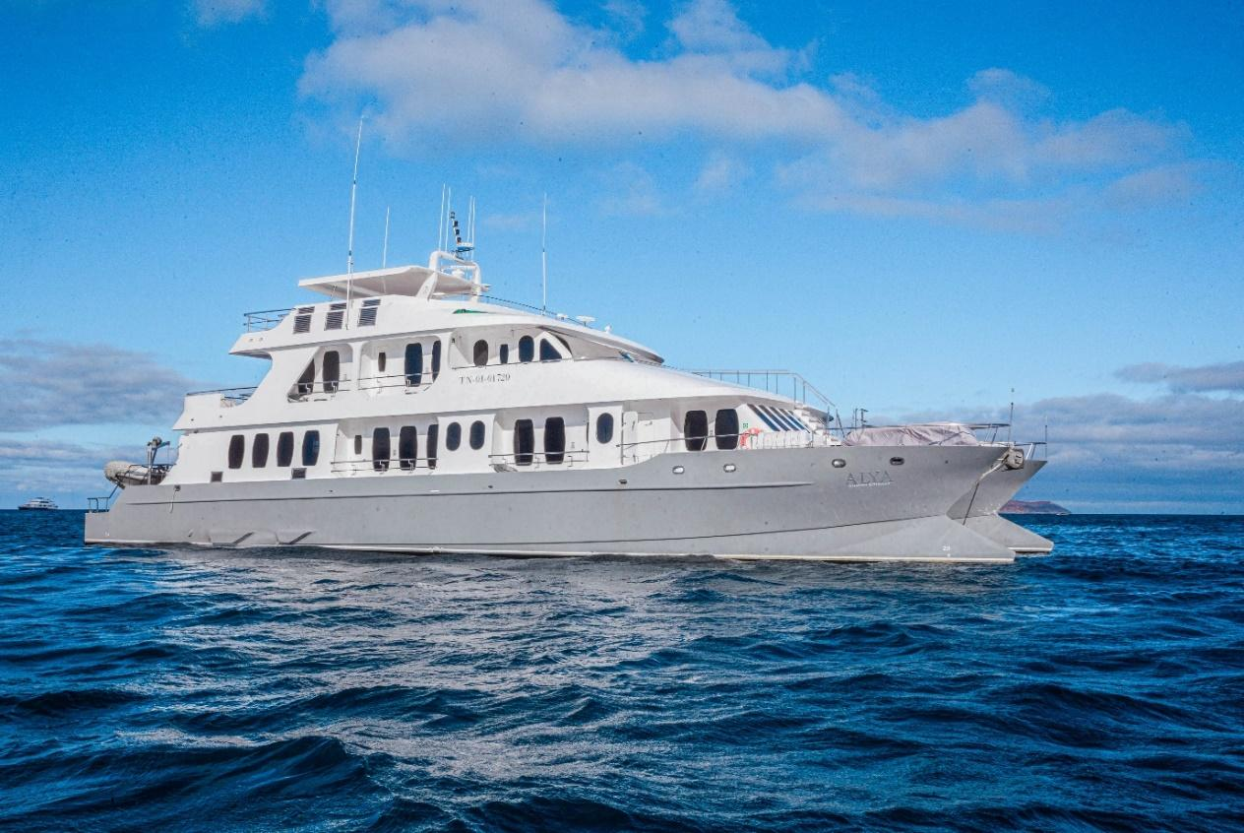

DAY 01: ALYA CATAMARAN: BALTRA AIRPORT AND NORTH SEYMOUR
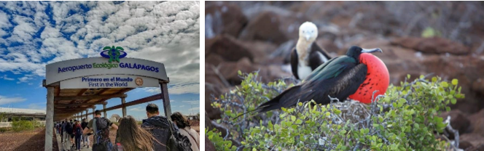

AM: BALTRA AIRPORT
Departure to the Galapagos Islands, arrival at Baltra airport, where our naturalist guide of the NationalPark will be waiting for you.

PM: SEYMOUR
This island is home for large colonies of both magnificent and great frigate birds and you can see them displaying their red balloons to attract a female. Blue-footed boobies’ nest in the ground and perform their famous dance in the open areas, while swallow-tailed gulls perch on the cliff edges. Land iguanas are common inland while their marine cousins bask in the rocks by the sea, close to sea lions, which often like to body surf in the waves.

Snorkel: This place is a really great snorkeling location, as it has tremendous diversity and amount of fish, but also sea lions, sharks, eels, turtles, rays and many more.

Accomodation: | M/C Alya
Included meals: | Lunch or Box lunch, Dinner

DAY 02: ALYA CATAMARAN: SOUTH PLAZAS AND SANTA FE ISLAND
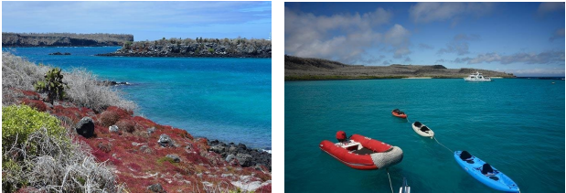

AM: PLAZAS
Of the two twin islands, only South Plazas is allowed to be visited, while North plazas is kept exclusively for scientific research. This is a small islet, but it packs an impressive amount of wildlife. Right after you land you will see Galapagos land iguanas waiting under prickly-pear cactus feed on their fruits. A large colony of sea lions will give you the opportunity to see playful pups enjoying the tide pools, but also large grumpy males defending their territories. The trail will take you to a cliff where you can observe many sea birds, such as frigatebirds, red-billed tropicbirds, boobies, swallow-tailed gulls and pelicans. A reddish succulent vegetation with scattered cactus covers most of the islands like a carpet, giving this island a unique personality.

PM: SANTA FE
Giant Prickly-pear cactus and barren lava rocks surround the landing spot at Santa Fe, located inside one of the most beautiful bays in the Galapagos. Turquoise water and white sand beaches make this location a perfect home for a large colony of sea lions which you will see basking in the sand. Inland, look down for endemic Santa Fe land iguanas, but also look up for Galapagos hawks, which often perch at the top of the cactus looking for prey. Darwin finches, Galapagos doves, mockingbirds and lava lizards are also common along the trail. Snorkel: After the hike, you will have the option to kayak or snorkel in the sheltered waters inside the bay, where you can swim with sea lion pups and reef sharks. Also look for sea turtles, rays and a large variety of tropical fish including large schools of surgeonfish and parrotfish.

Accomodation: | M/C Alya
Included meals: | Breakfast, Lunch, Dinner

DAY 03: ALYA CATAMARAN: INTERPRETATION CENTER AND LOBOS ISLAND
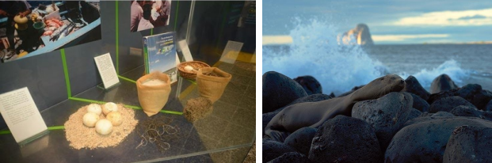

AM: INTERPRETATION CENTER
Located in the outskirts of Puerto Baquerizo, this center is dedicated to the history of human presence in the Galapagos. Since the times of the early Spanish explorers to the present times, including illustrious visitors such as Charles Darwin, this permanent exhibition will take you through the dangers and struggles of the first settlers trying to survive the harsh Galapagos environment.

PM: LOBOS ISLAND
Lobos island is a small islet separated from San Cristobal by a narrow channel, forming a sheltered bay where sea lion pups play in tidal pools. Despite its small size, the island is surprisingly packed with wildlife, especially with “lobos marinos”, the Spanish name for sea lions. Groups of sea lions will welcome you at the landing spot, but as you walk a few steps inland, male frigatebirds displaying their inflated red balloons will be perched on the bushes and trees. A small

colony of blue footed boobies, which often nest right on the trail, will give you the opportunity to observe their famous courtship dance.

Snorkel: This is a great snorkeling location as the water are usually calm and the sea lions often play with divers to show off their swimming skills. Sea turtles and rays are often seen resting in the sandy bottoms.

Accomodation: | M/C Alya
Included meals: | Breakfast, Lunch, Dinner

DAY 04: ALYA CATAMARAN: GARDER BAY AND SUAREZ POINT
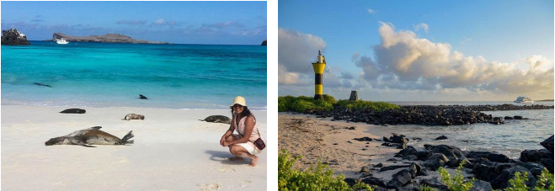

AM: GARDNER BAY
Gardner beach is undoubtedly one of the most beautiful and interesting beaches to visit in the Galapagos. Its fine coral sand and turquoise water give it a totally tropical appearance, which contrasts with the presence of sea lions basking in the beach. You will have the opportunity to walk along the beach and learn about the biology of sea lions and other endemic species, such as the Española mockingbird, marine iguanas and Galapagos hawks.

Snorkel: There are several great snorkeling places at Gardner bay. It is a fantastic site to swim with sea lions, reef sharks, rays and many species of fish, including; Angelfish, Parrotfish, Damselfish, Surgeonfish and many others.

PM: SUAREZ POINT
This rocky trail is one the most amazing nature walks you can do in the Galapagos islands. From the moment you set foot on the island and all the way along the trail the amount and diversity of fauna is truly amazing. Sea lions and marine iguanas will be the first ones welcoming us, followed by large colonies of sea birds, including Nazca and Blue-footed boobies, gulls and tropicbirds. At the end of the trail we will visit a colony of waved albatross (April to January), the largest bird in the islands and one of the most interesting because of its powerful flight and elaborate courtship. Waved albatross only nest at Española, so this is the only place where you will see them at close range.

Accomodation: | M/C Alya
Included meals: | Breakfast, Lunch, Dinner

DAY 05: ALYA CATAMARAN: CORMORANT POINT/DEVIL’S NOSE AND ALIERI HILL
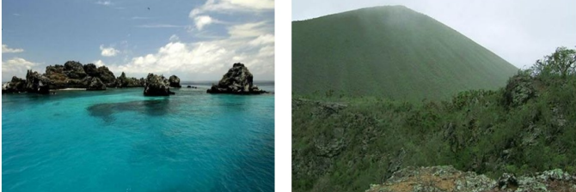

AM: CORMORANT POINT / DEVIL´S CROWN
Punta Cormorant is located in the north of Floreana and it is known for its large coastal lagoon with American flamingoes, whitecheeked pintails, black-necked stilts and other shorebirds. There is a beautiful white sand beach which is an important nesting ground for green sea turtles where we can also see rays and reef sharks. In the last years, a small group of blue footed boobies have started to breed right by the trail. This is also a great trail to look at endemic plants.

Snorkel: It will be done at Devil’s Crown, a heavily eroded little volcano right by Floreana island. This is considered by many as one of the best snorkeling sites in the entire archipelago as the current funnel’s plankton through the Crown, attracting huge schools of snapper, Creole fish parrot fish, angelfish, reef sharks, sea turtles, rays and a phenomenal amount of marine life.

PM: ALIERI HILL
Alieri hill is the remnant of an old volcano located in the transition zone of Floreana, 15 minutes away by bus from the town. This is one of the best locations for plant lovers, as the vegetation is largely native, with many endangered endemic species hard to find elsewhere. The views of the northern coast are also superb and there are interesting birds to look for, such as flycatchers, yellow warblers and Darwin finches.

Accomodation: | M/C Alya
Included meals: | Breakfast, Lunch, Dinner

DAY 06: ALYA CATAMARAN: HIGHLANDS OF SANTA CRUZ-FAREWALL GALAPAGOS
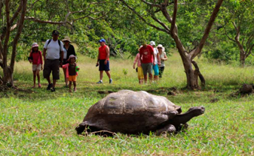
AM: HIGHLANDS
A bus will take you to the highlands stopping along the way at one of the reserves to visit the lush highland forests where you will look for Galapagos Giant tortoises in their natural environment. This is the best place in the Galapagos to see these gentle giants (reaching over 300 kg / 600 pounds!) casually grazing and resting in freshwater ponds. This is also home for a great diversity of birds rarely found at the lowlands, including finches (tree, woodpecker and vegetarian finches), flycatchers and several species of water birds. You will visit a lava tunnel (depend on the itinerary) and learn how these extraordinary formations where created by ancient volcanic eruptions.

Transfer to Baltra Airport and flight back to Ecuador mainland.

Accomodation: | ******
Included meals: | Breakfast

