GALAPAGOS ISLANDS
BONITA YACHT-ITINERARY C
5 DAYS AND 4 NIGHTS
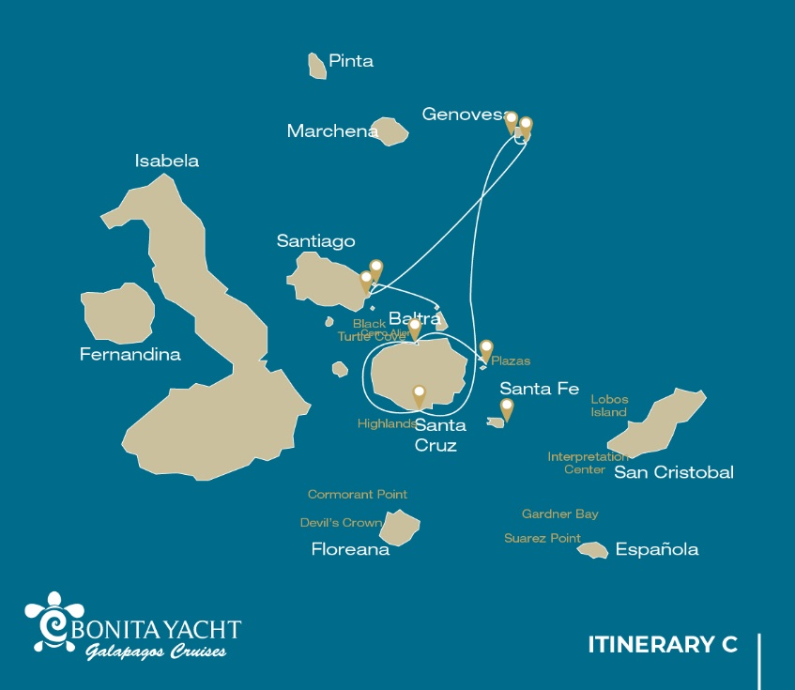

Itinerary C- 5 days
Day 1 | AM: Baltra airport  PM: Plazas
Day 2 | AM: Santa Cruz: Black Turtle Cove  PM: Santa Cruz: Highlands
Day 3 | AM:Genovesa: Darwin bay  PM: Genovesa: Barranco
Day 4 | AM: Santiago: Sullivan Bay  PM: Bartolome: Bartolome
Day 5 | AM: Seymour: Seymour  PM: Baltra airport

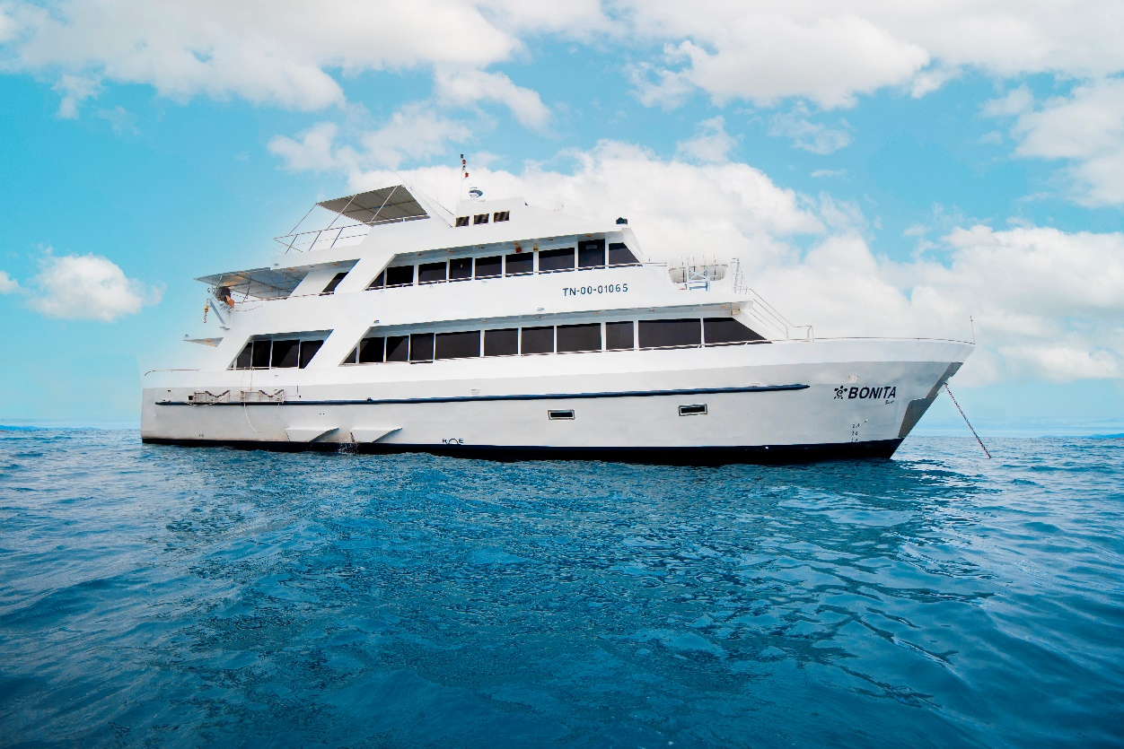

DAY 01: BONITA YACHT: BALTRA AIRPORT-SOUTH PLAZAS
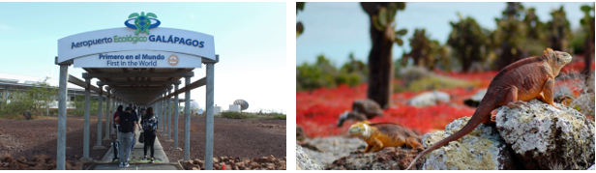
AM: BALTRA AIRPORT
Departure to the Galapagos Islands, arrival at Baltra airport, where our naturalist guide of the National Park will be waiting for you.

PM: PLAZAS
Of the two twin islands, only South Plazas is allowed to be visited, while North plazas is kept exclusively for scientific research. This is a small islet, but it packs an impressive amount of wildlife. Right after you land you will see Galapagos land iguanas waiting under prickly-pear cactus feed on their fruits. A large colony of sea lions will give you the opportunity to see playful pups enjoying the tide pools, but also large grumpy males defending their territories. The trail will take you to a cliff where you can observe many sea birds, such as frigatebirds, red-billed tropicbirds, boobies, swallow-tailed gulls and pelicans. A reddish succulent vegetation with scattered cactus covers most of the islands like a carpet, giving this island a unique personality.

Accomodation: | M/Y Bonita
Included meals: | Lunch or Box lunch, Dinner

DAY 02: BONITA YACHT: BLACK TURTLE COVE AND HIGHLANDS OF SANTA CRUZ
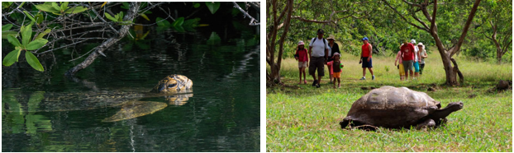
AM: BLACK TURTLE COVE
Black Turtle Cove gets its name from the abundance of green sea turtles, locally known as: “tortugas negras”. There is no landing here so you will be doing a boat tour on the dinghies, exploring shallow channels and small coves surrounded by beautiful mangrove forests. Reef sharks, sea turtles and several species of rays inhabit this beautiful area which is considered an important mating area for turtles and a nursery for several species of sharks. Herons, pelicans and boobies are also common here as they pray in schools of anchovies.

PM: HIGHLANDS
Either if you do this visit starting from Baltra or from Puerto Ayora, a bus will take you to the highlands stopping along the way at one of the reserves to visit the lush highland forests where you will look for Galapagos Giant tortoises in their natural environment. This is the best place in the Galapagos to see these gentle giants (reaching over 300 kg / 600 pounds!) casually grazing and resting in freshwater ponds. This is also home for a great diversity of birds rarely found at the lowlands, including finches (tree, woodpecker and vegetarian finches), flycatchers and several species of water birds. You will visit a lava tunnel (depending on the itinerary) and learn how these extraordinary formations were created by ancient volcanic eruptions.

Accomodation: | M/Y Bonita
Included meals: | Breakfast, Lunch, Dinner

DAY 03: BONITA YACHT: DARWIN BAY AND EL BARRANCO
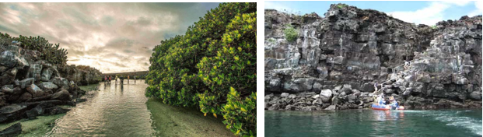

AM: DARWIN BAY
Genovesa is a favorite island for birdwatchers as it is home for very large colonies of seabirds. From the minute you set foot at the beach you will be amazed by the noise of hundreds of boobies, gulls and frigatebirds flying over your heads, perched in the bushes or nesting on the sandy terrain. The trail is an ultimate wildlife experience as there are animals everywhere; sea lions and marine iguanas near the sea; night herons, lava & swallow tailed gulls, Darwin finches, Galapagos doves, mockingbirds and many more species inland.

Snorkel: The bay offers several places to snorkel; from deep waters along the cliffs across the bay, to shallow waters by the beach. In either case, there are many fish to see and great chances of seeing sharks, rays and sea lions.

PM: EL BARRANCO
El Barranco is located in the southern part of Darwin Bay at Genovesa Island. The cliffs facing the sea are made of very fragile fractured lava, making it the ideal place for storm petrels to build their colonies, which attracts an important population of short-eared owls preying on the nesting birds. Red footed and Nazca boobies are abundant along the trail. At the base of the cliffs you can see Galapagos fur seals resting in shaded areas, as well as several species of seabirds.

Snorkel: You can snorkel along the cliffs where there are many fish and great chances of seeing sharks, rays and sea lions.

Accomodation: | M/Y Bonita
Included meals: | Breakfast, Lunch, Dinner

DAY 04: BONITA YACHT: SULLIVAN BAY AND BARTOLOME ISLAND
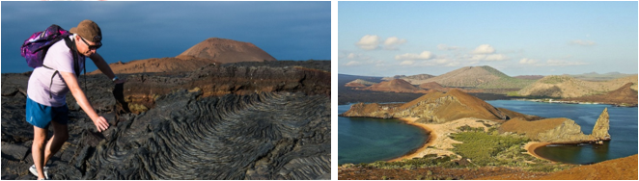

AM: SULLIVAN BAY
This hike is a journey into understanding the birth of these volcanic islands. You will walk in a very well preserved flow of Pahoehoe lava, which will give you endless opportunities to see the delicate textures of these types of lavas which only appear in a few places throughout the world. At first sight the barren landscape looks completely deprived of life, but look carefully for pioneer plants, lava lizards and small birds. By the shore, you can find penguins, pelicans and oystercatchers.

Snorkel: You will have the option to swim or snorkel from a coral sand beach or from the dinghies. Getting underwater is like traveling to another world: if the land is almost lifeless, the sea is teaming with life, including large schools of fish, Galapagos penguins, reef sharks, turtles and rays.

PM: BARTOLOME
Bartolome is one of the most iconic places in the Galapagos and one of the few where you can see penguins without going to the remote areas of western Isabela and Fernandina. You will get great views of Pinnacle Rock, located on the northern side of the island, right next to a beautiful peach-color sand beach.
The hike to the top of the island is fantastic and will offer you incredible views of lunar landscapes with scattered volcanic cones. Many islands are visible from this outlook, as well as the bay of Sullivan and the Pinnacle rock.

Snorkel: You will have the option to swim or snorkel from the beach. This area holds a well-deserved reputation of being one of the best snorkeling places in the Galapagos, not only because it’s clear and calm water, but also because of the presence of penguins, which are relatively easy to find while snorkeling, along with an incredible diversity of fish, colorful invertebrates, sea lions, turtles, rays and reef sharks.

Accomodation: | M/Y Bonita
Included meals: | Breakfast, Lunch, Dinner

DAY 05: BONITA YACHT: NORTH SEYMOUR-FAREWALL GALAPAGOS
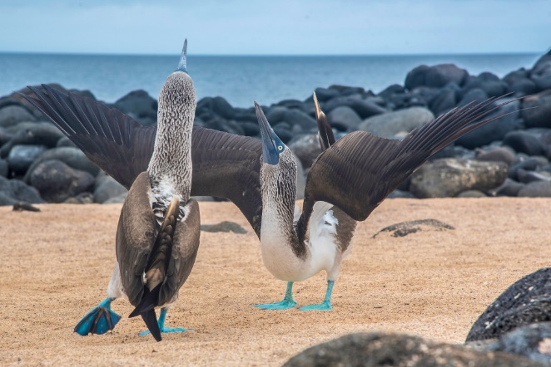
AM: SEYMOUR
This island is home for large colonies of both magnificent and great frigatebirds and you can see them displaying their red balloons to attract a female. Blue-footed boobies nest in the ground and perform their famous dance in the open areas, while swallow-tailed gulls perch on the cliff edges. Land iguanas are common inland while their marine cousins bask in the rocks by the sea, close to sea lions, which often like to body surf in the waves.

Transfer to the airport and flight back to Ecuador mainland.

Accomodation: | *****
Included meals: | Breakfast

