GALAPAGOS ISLANDS
GALAXY DIVER II-DIVING ITINERARY
8 DAYS AND 7 NIGHT
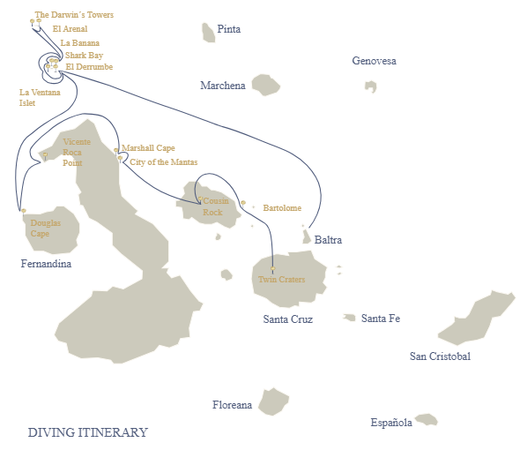
Diving Itinerary
Day 1 | AM: Baltra airport  PM: Northesast of Baltra
Day 2 | AM: Santa Cruz: Carrion Point  PM: Navigation to Wolf
Day 3 | AM: Wolf Island: Shark Bay/La Banana  PM: Wolf Island: La Ventana Islet/El Derrumbe
Day 4 | AM: Darwin Island: El Arenal  PM: Darwin Island: the Darwin´s Arch
Day 5 | AM: Darwin Island: El Arenal  PM: Wolf Island: El Derrumbe and Shark Bay
Day 6 | AM: Fernandina Island: Douglas Cape  PM: Isabela Island: Vicente Roca Point
Day 7 | AM: Santiago Island: Cousin Rock  PM: Santa Cruz Island: Highlands
Day 8 | AM: Baltra airport

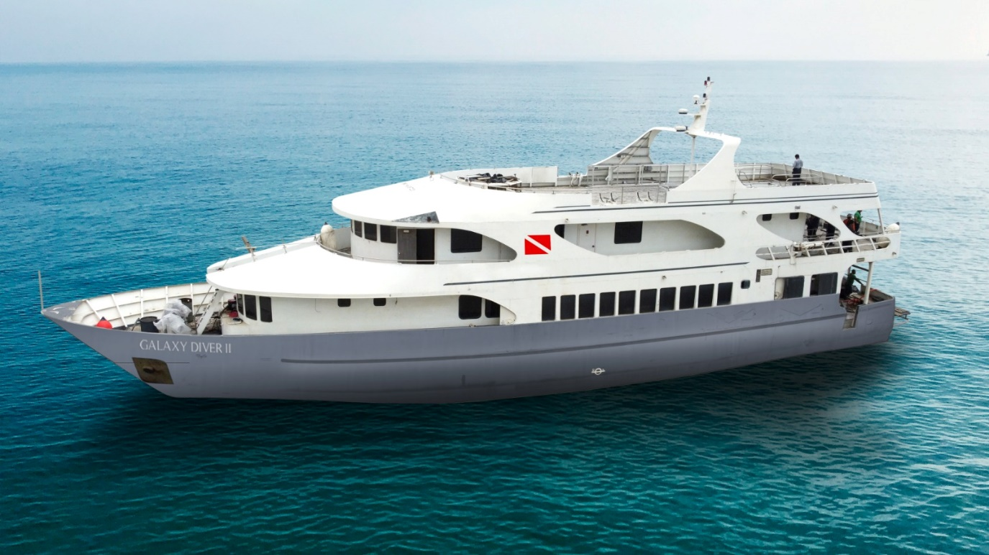

DAY 01: GALAXY DIVER II: BALTRA AIRPORT- NORTHEAST OF BALTRA

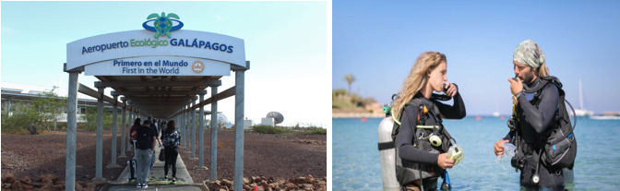

AM: BALTRA AIRPORT
Welcome to the GalapagosIslands, where today marksthe beginning of our diving adventure onboard the Galaxy Diver liveaboard yacht. Our journey starts with our arrival at Seymour Airport, also known as Baltra Airport, located on the island of Baltra. As we step off the plane, we'll be greeted by our guide and the friendly staff of the Galaxy Diver, who will help us with our luggage and transfer us to the Galaxy Diver.

PM: NORTHEAST OF BALTRA
The safety drill and check dive to try all the equipment by having our first immersion among the wonders of the Galapagos Islands. With the Galaxy Diver as our home base, we'll explore the pristine waters and encounter incredible marine life that can't be found anywhere else. It's sure to be an unforgettable experience that will leave us with memories to last a lifetime.

Inmmersions: 1 (check dive)

Accomodation: | M/Y Galaxy Diver II
Included meals: | Lunch or Box lunch, Dinner

DAY 02: GALAXY DIVER II: CARRION POINT AND NAVIGATION TO WOLF
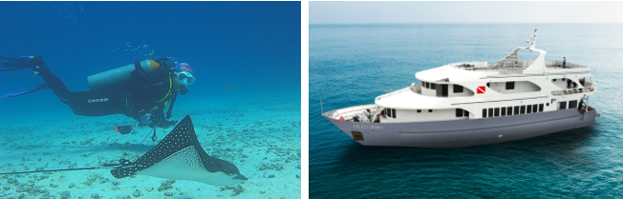

AM: CARRION POINT
As the sun rises on our first day of diving aboard the Galaxy Diver yacht, we can feel the excitement building for what's in store at our first dive site, Punta Carrion. We gather our gear, and with the guidance of our expert dive master instructors, we dive into the crystal-clear waters surrounding the stunning Santa Cruz Island. Descending deeper into the underwater world of Punta Carrion, we'll be immediately mesmerized by the incredible visibility and the abundance of marine life that surrounds us—schools of hammerhead and whale sharks, this last one available between June to December. At the same time, playful sea lions dart in and out of the rocky underwater cliffs.

PM: NAVIGATION TO WOLF
In the late afternoon, we'll begin our 14 hours of navigation through the Galapagos Sea to Wolf Island.

Inmmersions: 2

Accomodation: | M/Y Galaxy Diver II
Included meals: | Breakfast, Lunch, Dinner

DAY 03: GALAXY DIVER II: SHARK BAY/LA BANANA AND LA VENTANA ISLET/EL DERRUMBE
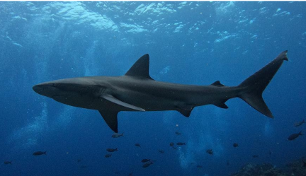

AM: SHARK BAY/LA BANANA
Today, we'll have an exciting diving adventure as we discover the hidden riches of this enchanted location. Our first stop is the breathtaking Shark Bay, where we can spot the majestic Galapagos shark, eagle ray, and sea lion will meet you as you plunge into the ocean's depths. These magnificent creatures are a sight to behold, with exquisite movements that will take your breath away.
Following a thrilling morning dive, we'll travel to La Banana to continue our journey and discover the GalapagosIslands' abundant marine life. In addition, we'll be able to see playfulsea lionsin their native environment, darting and whirling about us with elegant, engaging, and mesmerizing beauty.

PM: LA VENTANA ISLET/EL DERRUME
As the day unfolds, we'll make our way to La Ventana Islet and El Derrumbe, two diving locations known for their diverse marine life. Go into the fascinating world of colorful fish, turtles, and sea stars www.galaxydiveronboard.com asthey welcome you into their natural home. The beauty and magic of the undersea environment will wow you as you explore

these hidden jewels. As we wrap up our diving day, take a minute to enjoy the beautiful sunset while reflecting on the incredible experiences of the day. The GalapagosIslands are indeed a treasure trove of natural beauty, and we are privileged to accompany you on this magnificent voyage. Therefore, be ready to immerse yourself in a world of wonder and go on a once-in-a-lifetime experience!

Inmmersions: 4

Accomodation: | M/Y Galaxy Diver II
Included meals: | Breakfast, Lunch, Dinner

DAY 04: GALAXY DIVER II: EL ARENAL AND DARWIN’S ARCH
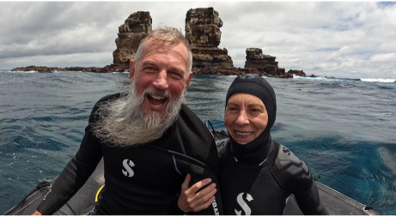
AM: EL ARENAL
Today, we'll take you to El Arenal. This magnificent location will leave you spellbound by the natural beauty of the Galapagos Islands. A diving site considered one of the best diving points in the world. This site is close to Darwin's Arch and offers moderate to strong currents with depths ranging from 46 to 121 ft and visibility from 40 to 80 ft. As you dive deeper into the sea, you'll be greeted by the impressive Galapagos underwater biodiversity.

PM: DARWIN´T TOWERS
We'll then move on to Darwin's Tower, commonly known as Darwin's Arch, one of the most iconic dive sites in the world. This awe-inspiring location is a must-visit for any avid diver. We're thrilled to share this incredible experience with you. As you dive into the deep blue waters, a world of vibrant www.galaxydiveronboard.com coral, schools of colorful fish, and the majestic beauty of the hammerhead shark will be waiting for you with their imposing presence and graceful movements. The thrill of diving at Darwin's Towerisindescribable, and you'll be amazed by the sheer beauty of this underwater wonderland.

Inmmersions: 4

Accomodation: | M/Y Galaxy Diver II
Included meals: | Breakfast, Lunch, Dinner

DAY 05: GALAXY DIVER II: EL ARENAL AND EL DERRUMBRE AND SHARK BAY
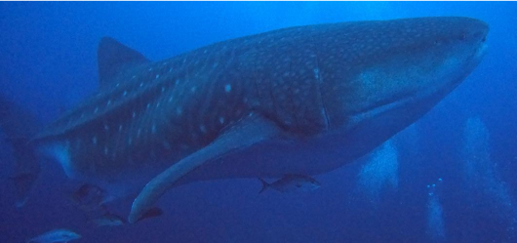
AM: EL ARENAL AND EL DERRUMBE
As we explore the vibrant coral reefs and discover the diverse marine life, we'll have the chance to encounter an incredible array of species. Some of them could be dolphins commonly sighted feeding on schools of fish, hammerhead sharks, whale sharks, rays, Galapagos sharks, and even tiger sharks and killer whales. But the beauty of El Arenal isn't just in its impressive marine life; the geological formations are also a sight to behold.

PM: SHARK BAY
Our last dive of the day takes us to Shark Bay, where we'll explore the hidden treasures of the Galapagos Islands. This site is famous for its incredible diversity of marine life, including the Galapagos shark, eagle ray, and sea lion. But what makes this site truly unique is the presence of whale sharks that visit the Galapagos Islands every year from July to November. It's a rare opportunity to witness these gentle giants, and we're honored to share this experience with you.

Inmmersions: 4

Accomodation: | M/Y Galaxy Diver II
Included meals: | Breakfast, Lunch, Dinner

DAY 06: GALAXY DIVER II: DOUGLAS CAPE AND VICENTE ROCA POINT
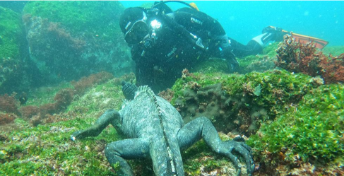
AM: DOUGLAS CAPE
We start our day by diving at Douglas Cape, where you can observe the marine iguanas feeding on algae underwater. These graceful creatures spend time basking in the sun to warm up before diving into the sea for about 20 minutes to feed. Watching them glide through the water is a truly unforgettable experience. The seas surrounding Douglas Cape are teeming with unique marine life, such as the famous Galapagos marine iguana, red-lipped batfish, fur seals, Galapagos penguins, and flightless cormorants.

PM: VICENTE ROCA POINT
Our following dive site is Vicente Roca Point, located on the northwest coast of Isabela Island. The abundance of colorful corals and gorgonians make this site one of the best in the Galapagos Islands for enjoying macro life, such as seahorses, different species of nudibranchs, toadfish, and even the elusive Mola Alexandrini (mola mola), the largest bony fish in the world. You may also encounter penguins and flying cormorants, green turtles, and, if lucky, a catshark. The stunning coral formations and the impressive array of marine life at Vicente Roca Point will take your breath away.

Inmmersions: 2

Accomodation: | M/Y Galaxy Diver II
Included meals: | Breakfast, Lunch, Dinner

DAY 07: GALAXY DIVER II: COUSIN ROCK AND HIGHLANDS
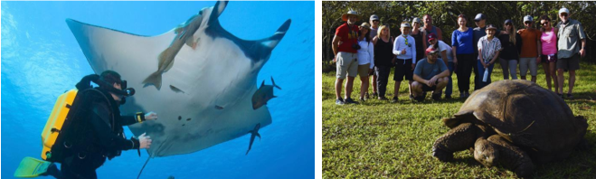
AM: COUSIN ROCK
This morning we'll have the opportunity to do our last dive at Cousin Rock—one of the most colorful dive sites in the archipelago. The vibrant coral walls and gorgonians create a stunning backdrop for encounters with seahorses, reef fish, and various nudibranchs. Keep an eye out for the curious coral hawks as they dart around the reef. As we dive deeper, we might glimpse a school of eagle rays gracefully gliding by or spot a white-tip shark resting in a crevice. If we're lucky, we might even see mobulas and schools of barracudas. Finally, the playful sea lions will appear and invite us to join their underwater games.

PM: HIGLANDS OF SANTA CRUZ
A bus will take you to the highlands stopping along the way at one of the reserves to visit the lush highland forests where you will look for Galapagos Giant tortoises in their natural environment. This is the best place in the Galapagos to see these gentle giants (reaching over 300 kg / 600 pounds!) casually grazing and resting in freshwater ponds. This is also home for a great diversity of birds rarely found at the lowlands, including finches (tree, woodpecker and vegetarian finches), flycatchers and several species of water birds. You will visit a lava tunnel (depend on the itinerary) and learn how these extraordinary formations where created by ancient volcanic eruptions.

Inmersions: 2
Accomodation: | M/Y Galaxy Diver II
Included meals: | Breakfast, Lunch, Dinner

DAY 08: GALAXY DIVER II: BALTRA AIRPORT
After a week of unforgettable experiences, it is time to bid farewell to this enchanting land. As you'll be transferred to Baltra Airport, take the memories of a lifetime and the magic of the Galapagos Islands.

Inmmersions: 0

Accomodation: | *****
Included meals: | Breakfast

