GALAPAGOS ISLANDS
ECOGALAXY CATAMARAN-ITINERARY B
6 DAYS AND 5 NIGHTS

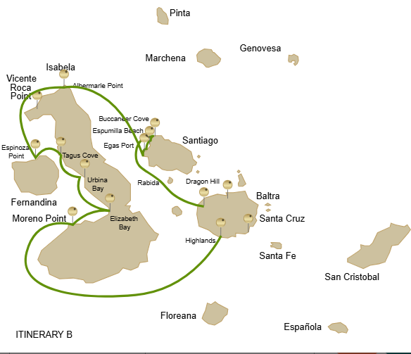

Itinerary B- 6 days
Day 1 | AM: Baltra airport  PM: Santa Cruz: Highlands
Day 2 | AM: Isabela: Moreno Point  PM: Isabela: Elizabeth bay
Day 3 | AM:Isabela: Urbina bay  PM: Isabela: Tagus Cove
Day 4 | AM: Fernandina: Espinoza Point  PM: Isabela: Albermarle Point
Day 5 | AM: Santiago: Egas Port  PM: Santiago: Espumilla Beach/ Buccaneer Cove
Day 6 | AM: Santa Cruz: Dragon Hill/Daphne  PM: Baltra airport

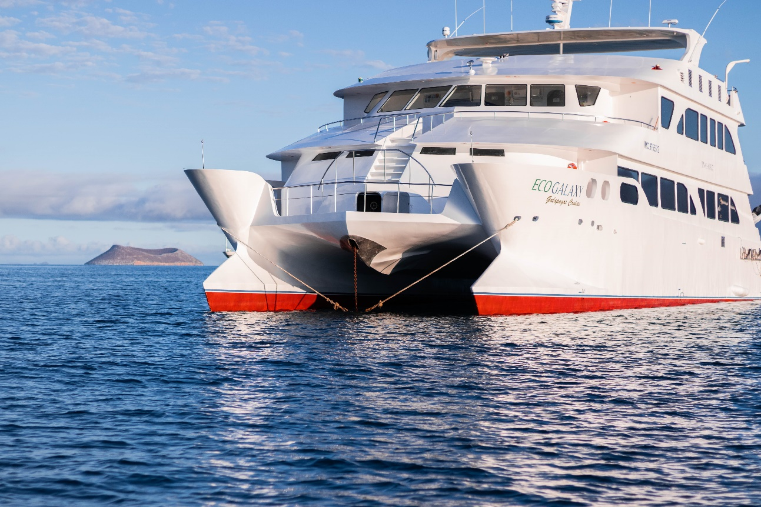

DAY 01: ECOGALAXY CATAMARAN: BALTRA AIRPORT AND HIGHLANDS

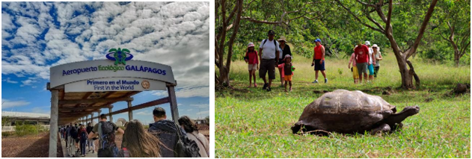

AM: BALTRA AIRPORT
Departure to the Galapagos Islands, arrival at Baltra airport, where our naturalist guide of the NationalPark will be waiting for you.

PM: HIGHLANDS OF SANTA CRUZ
A bus will take you to the highlands stopping along the way at one of the reserves to visit the lush highland forests where you will look for Galapagos Giant tortoises in their natural environment. This is the best place in the Galapagos to see these gentle giants (reaching over 300 kg / 600 pounds!) casually grazing and resting in freshwater ponds. This is also home for a great diversity of birds rarely found at the lowlands, including finches (tree, woodpecker and vegetarian finches), flycatchers and several species of water birds. You will visit a lava tunnel (depend on the itinerary) and learn how these extraordinary formations were created by ancient volcanic eruptions

Accomodation: | M/C EcoGalaxy
Included meals: | Lunch or Box lunch, Dinner

DAY 02: ECOGALAXY CATAMARAN: MORENO POINT AND ELIZABETH BAY
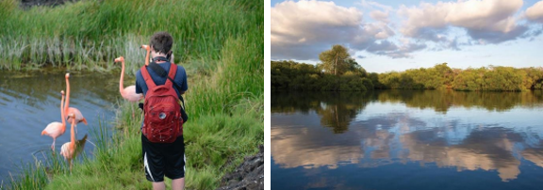

AM: MORENO POINT
Moreno Point is a magical place with extensive lava fields which look lifeless at first sight. Once inland, scattered brackish lagoons form oasis of life where you can find flamingoes, gallinules, ducks and herons. Along the shore we

will look for penguins, marine iguanas, flightless cormorants, blue-footed boobies, sea lions, oystercatchers and other shore birds.

Snorkel: We will snorkel to see sea turtles, cormorants and many species of fish. Look carefully in the
long seaweeds and you might find a sea horse

PM: ELIZABETH BAY
Elizabeth Bay is a beautiful sheltered bay surrounded by large mangroves and barren lava fields.There is no trail here so you will take a dinghy tour to explore many channels, pools and coves teeming with life. This is one of the best locations in the islands to see Galapagos penguins, but don’t expect to see thousands of them, as the entire population
of the islands is only about 3.000 of them. Flightless cormorants also nest in the area and blue-footed boobies and pelicans often fish in these shallow and rich waters. Rays and sea turtles are also very abundant.

Accomodation: | M/C EcoGalaxy
Included meals: | Breakfast, Lunch, Dinner

DAY 03: ECOGALAXY CATAMARAN: URBINA BAY AND TAGUS COVE

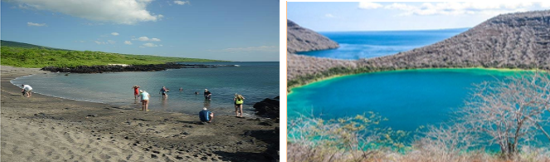
AM: URBINA BAY
This place is known for the dramatic uplifting that happened here during the 1950’s. A large portion of the coast was pushed up, exposing many hectares of previously submerged land. Look carefully along the trail and you will find small shells and corals, a proof that the area was underwater more than sixty years ago. The trail will give the opportunity to see land iguanas and, during certain seasons, giant tortoises. Galapagos hawks nest in the area and are often seen flying or perched on the trees.

Snorkel: You can snorkel from the beach to see sea turtles, cormorants and penguins. Fish are also abundant in the area.

PM: TAGUS COVE
Tagus cove is one of the places Charles Darwin visited during his exploration of the Galapagos islands. A trail will take you through a dry Palo Santo forests where you can see Darwin finches and mockingbirds. You will get great views of Darwin’s lake and the large volcanos of northern Isabela. A boat tour along the shore will give you chances to see penguins, cormorants, marine iguanas and a very unique species: the Galapagos martin, a small endemic bird which is one of the most endangered species on the island.

Snorkel: The nutrient -rich waters around Tagus Cove attracts a lot of sea turtles and a great diversity of fish, but also penguins, who feast on large schools of anchovies. It is common to see cormorants underwater as they chase fish through the reef.

Accomodation: | M/C EcoGalaxy
Included meals: | Breakfast, Lunch, Dinner

DAY 04: ECOGALAXY CATAMARAN: ESPINOZA POINT AND ALBERMARLE POINT
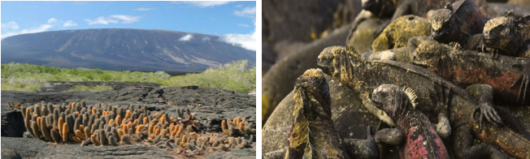

AM: ESPINOZA POINT
Begin your day at Espinoza Point, located at the base of an imposing volcano - the most active in the Galapagos islands. This site, one of the crown jewels of the Galapagos National Park, presents a unique spectacle right from the moment you step ashore. Hundreds of marine iguanas, forming the largest colony of the species, greet you upon arrival. Sea lions lounge on the beaches, their pups playfully exploring the tide pools. Along the shore, catch sight of flightless cormorants, a species confined to the western areas of the archipelago. Blessed with cold, plankton-rich waters, Punta Espinosa is a sanctuary for diverse species, including herons, pelicans, oystercatchers, sea turtles, shorebirds, and more. Also, keep an eye on the mangroves where Galapagos hawks often perch, scanning for prey.

Snorkeling Experience: The nutrient-dense waters around Punta Espinosa attract a myriad of fish and sea turtles. The abundant seaweed makes this spot an ideal location to watch marine iguanas feed underwater. Following a cormorant underwater as it chases fish through the reef will undoubtedly be one of the most incredible snorkeling experiences you'll have on your trip.

PM: ALBEMARLE POINT
In the afternoon, visit Albemarle Point, where wildlife and history intersect. During World War II, the Americans constructed a radar base here to detect the presence of Japanese warships approaching the Galapagos. The remains of the radar can still be seen today. Despite being barren and surrounded by infinite lava fields, the coast is home to some of the largest marine iguanas on the islands, Galapagos penguins, flightless cormorants, and shorebirds.

Snorkeling Experience: A couple of sheltered coves here provide excellent opportunities for snorkeling, offering views of cormorants, penguins, and various fish species

Accomodation: | M/C EcoGalaxy
Included meals: | Breakfast, Lunch, Dinner

DAY 05: ECOGALAXY CATAMARAN: EGAS PORT AND ESPUMILLA BEACH/ BUCANEER COVE
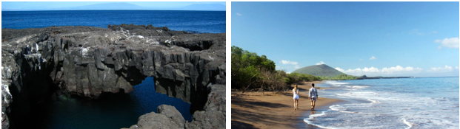
AM: EGAS PORT
Despite its misleading name, there isn't a traditional "port" at Puerto Egas, yet some remnants of past attempts to colonize the island during the 1960s can still be seen. The trail here follows the coastline, an area rich in wildlife. You will see marine iguanas basking in the sun everywhere you turn, along with Galapagos sea lions, herons, oystercatchers, and many shorebirds. Towards the trail’s end, you'll encounter "the grottos,” home to a small colony of the elusive endemic Galapagos fur seal, much more challenging to spot than its cousin. As recently as 2019, land iguanas were reintroduced to the area, so keep an eye out for these impressive reptiles, which had been extinct from Santiago for over a century.

Snorkeling Experience: A snorkeling session from the beach will lead you to an area of rocky bottoms, excellent for observing fish, turtles, and reef sharks. Sea lions often frequent this area and are typically open to interacting with divers.

PM: ESPUMILLA BEACH / BUCCANEER COVE
Espumilla Beach, located on the northern coast of Santiago, is a stunning 1km (0.6 mi) long expanse of rusty-brown sand. The beach is surrounded by large mangrove trees and a fascinating native dry forest, which houses Galapagos hawks and a wide variety of finches, mockingbirds, and doves. Don't forget to check the salt pan; it could be home to flamingoes and ducks during the rainy season. Buccaneer Cove, named for its use by pirates and buccaneers during the 17th and 18th centuries as a hiding place and source of freshwater and tortoises, is an incredibly scenic site with beautiful cliffs and interesting rock formations. Although there's no trail here, you will take a dinghy ride to observe the wildlife from the small boats.

Snorkeling Experience: In a sheltered bay, snorkel among underwater wildlife, including large schools of fish (angelfish, puffers, parrotfish, snappers, grunts...), reef sharks, sea lions, and sea turtles.

Accomodation: | M/C EcoGalaxy
Included meals: | Breakfast, Lunch, Dinner

DAY 06: ECOGALAXY CATAMARAN: DRAGON HILL- FAREWALL GALAPAGOS
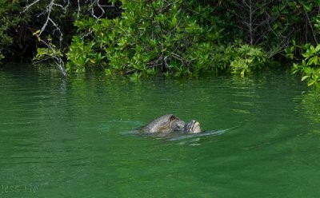

AM: DRAGON HILL/DAPHNE
Explore one of the two remarkable sites in Galápagos: Dragon Hill on Santa Cruz, where land iguanas roam and flamingos gather at a saltwater lagoon, and Daphne Major, home to nesting seabirds and groundbreaking finch evolution research. Both offer unique, unforgettable wildlife experiences.

Highlights: Herons, Darwin finches, Galapagos flycatchers, American flamingoes, Galapagos land iguanas

Transfer to Baltra airport and flight back to Ecuador mainland.

Accomodation: | *****
Included meals: | Breakfast

