GALAPAGOS ISLANDS
ECOGALAXY CATAMARAN-ITINERARY C
6 DAYS AND 5 NIGHTS

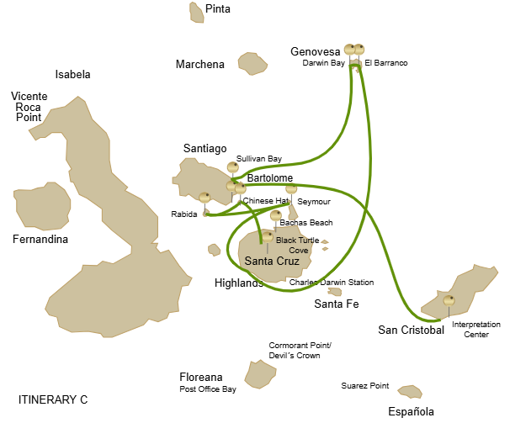
Itinerary C- 6 days
Day 1 | AM: Baltra airport  PM: Santa Cruz: Black Turtle Cove
Day 2 | AM: Chinese Hat: Chinese Hat  PM: Rabida: Rabida
Day 3 | AM:Seymour Island: Noth Seymour  PM: Santa Cruz: Highlands
Day 4 | AM: Genovesa: El Barranco  PM: Genovesa: Darwin Bay
Day 5 | AM: Santiago: Sullivan Bay  PM: Bartolome: Bartolome
Day 6 | AM: San Cristobal: Interpretation Center  PM: San Cristobal airport

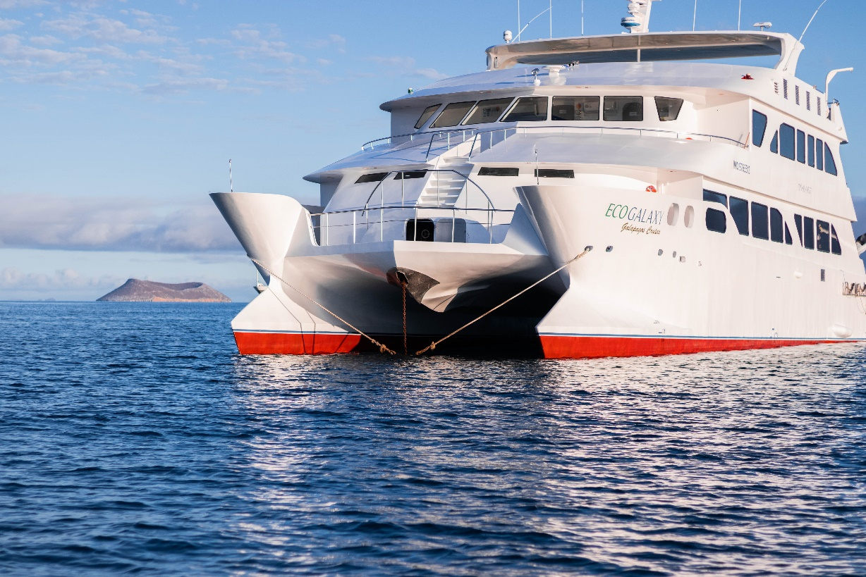

DAY 01: ECOGALAXY CATAMARAN: BALTRA AIRPORT AND BLACK TURTLE COVE
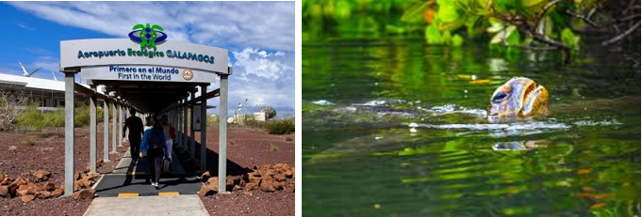
AM: BALTRA AIRPORT
Departure to the Galapagos Islands, arrive at Baltra airport, where a National Park-certified naturalist guide will warmly welcome you to this biodiversity-rich paradise. Your exciting journey in the footsteps of Darwin is about to start!

PM: BLACK TURTLE COVE
At Black Turtle Cove, named for the abundant green sea turtles, locally known as "Tortugas Negras," you're in for a delightful boat tour onboard the dinghies. Your adventure here is a peaceful exploration of shallow channels, small coves, and beautiful mangrove forests surrounding the area. Reef sharks, sea turtles, and several species of rays inhabit this tranquil sanctuary, which is considered a crucial mating area for turtles and a nursery for various shark species. Look out for herons, pelicans, and boobies who make this their feeding ground, preying on schools of anchovies. There's no landing at Black Turtle Cove. Still, the rich biodiversity experienced from the boat more than makes up for it, offering up-close encounters with the wonderful marine life of the Galapagos.

Accomodation: | M/C EcoGalaxy
Included meals: | Lunch or Box lunch, Dinner

DAY 02: ECOGALAXY CATAMARAN: CHINESE HAT AND RABIDA

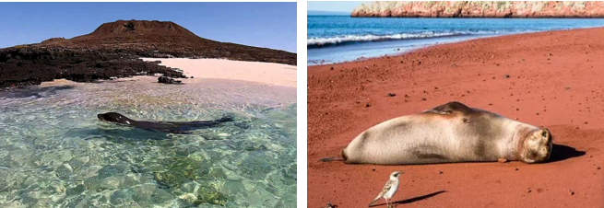

AM: CHINESE HAT
Named for its distinctive cone shape, Chinese Hat is a small islet separated from Santiago by a narrow channel, forming one of Galapagos’ most picturesque bays. Its turquoise waters, coral-sand beaches, and volcanic rocks create a stunning landscape. A coastal trail leads you through a sea lion colony, while on the lava rocks, you may spot penguins resting. This site perfectly blends breathtaking scenery with Galapagos’ remarkable wildlife, making for an unforgettable experience.

Snorkel Experience: Snorkel into the crystal-clear waters of Chinese Hat and marvel at the vibrant colors of the fish. Spot sleek reef sharks and, if lucky, a penguin darting through the water like a swift underwater torpedo chasing anchovies.

Highlights: Lava tubes, Galapagos sea lions, Galapagos penguins, Oystercatchers, Galapagos hawks

PM: RABIDA
Rabida is a small island famous for its reddish lava rocks (rich in iron) which gives it a unique look. The beach is also red and hosts a small colony of sea lions. There is a small salt water lagoon where we will see ducks and stilts and sometimes flamingoes. The trail will take you inland to get beautiful views of the beach and the lagoon. Look for Darwin finches, flycatchers and mockingbirds. In the cliffs along the coast you can find Nazca and blue-footed boobies, brown noddy, herons and the two species of sea lions: Galapagos and fur seals.
Snorkel Experience: You can snorkel from the beach and explore a sheltered rocky area, which is excellent for fish, sea lions and reef sharks. Look at the high diversity of small invertebrates attached to the vertical walls.

Highlights: Red-sand beach, Galapagos sea lions, Galapagos hawks, Darwin finches, Galapagos flycatchers

Accomodation: | M/C EcoGalaxy
Included meals: | Breakfast, Lunch, Dinner

DAY 03: ECOGALAXY CATAMARAN: SEYMOUR AND HIGHLANDS

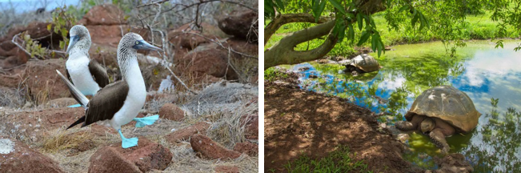

AM: NORTH SEYMOUR
This island is home for large colonies of both magnificent and great frigatebirds and you can see them displaying their red balloons to attract a female. Blue-footed boobies nest in the ground and perform their famous dance in the open

areas, while swallow-tailed gulls perch on the cliff edges. Land iguanas are common inland while their marine cousins bask in the rocks by the sea, close to sea lions, which often like to body surf in the waves.

Snorkel Experience: This place is a really great snorkeling location, as it has tremendous diversity and amount of fish, but also sea lions, sharks, eels, turtles, rays and many more.

Highlights: Galapagos sea lions, Magnificent and great frigatebirds, Land and marine iguanas, Darwin finches

PM: HIGHLANDS
Either if you do this visit starting from Baltra or from Puerto Ayora, a bus will take you to the highlands stopping along the way at one of the reserves to visit the lush highland forests where you will look for Galapagos Giant tortoises in their natural environment. This is the best place in the Galapagos to see these gentle giants (reaching over 300 kg / 600 pounds!) casually grazing and resting in freshwater ponds. This is also home for a great diversity of birds rarely found at the lowlands, including finches (tree, woodpecker and vegetarian finches), flycatchers and several species of water birds. You will visit a lava tunnel (depending on the itinerary) and learn how these extraordinary formations were created by ancient volcanic eruptions.

Accomodation: | M/C EcoGalaxy
Included meals: | Breakfast, Lunch, Dinner

DAY 04: ECOGALAXY CATAMARAN: EL BARRANCO Y DARWIN BAY
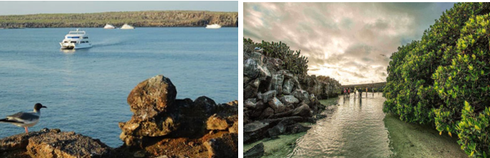
AM: EL BARRANCO
Located in the southern part of Darwin Bay on Genovesa Island, El Barranco is blessed with cliffs facing the sea made from very fragile, fractured lava. This creates an ideal nesting environment for storm petrels, attracting a significant population of short-eared owls. The trail is dotted with red-footed and Nazca boobies. At the same time, the base of the cliffs provides restful, shaded areas for Galapagos fur seals and numerous seabirds.

Snorkeling Experience: Snorkeling alongside these cliffs is an exhilarating experience, teeming with diverse fish and providing great chances to see sharks, rays, and playful sea lions.

PM: DARWIN BAY
Darwin Bay on Genovesa Island is a birder's dream come true. When you set foot on the beach, you will be amazed by the spectacle of hundreds of boobies, gulls, and frigatebirds soaring above, nesting in the bushes, or roosting on the sandy terrain. This immersive wildlife trail hosts sea lions and marine iguanas by the sea, and inland you'll encounter night herons, lava and swallow-tailed gulls, Darwin finches, Galapagos doves, mockingbirds, and more.

Snorkeling Experience: Darwin Bay offers a variety of snorkeling locations, from deep waters along the bay's cliffs to shallow waters near the beach. Regardless of where you choose, a colorful variety of fish awaits your visit, with a high chance of spotting sharks, rays, and sea lions

Accomodation: | M/C EcoGalaxy
Included meals: | Breakfast, Lunch, Dinner

DAY 05: ECOGALAXY CATAMARAN: SULLIVAN BAY AND BARTOLOME

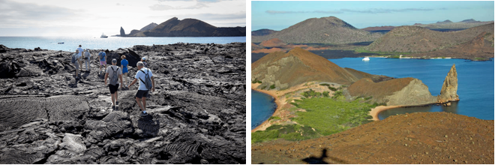
AM: SULLIVAN BAY
Walking through Sullivan Bay offers an extraordinary journey into the volcanic origins of the Galapagos Islands. Your hike will take you across a perfectly preserved Pahoehoe lava flow, providing endless opportunities to observe the delicate textures of this rare type of lava. While the landscape may appear barren and lifeless at first, a closer look reveals resilient pioneer plants, scurrying lava lizards, and small birds. Along the shore, penguins, pelicans, and oystercatchers add a touch of life to the stark environment.

Snorkeling Experience: Following the hike, you can swim or snorkel from a coral sand beach or the dinghies. The underwater world here starkly contrasts the sparse land, teeming with schools of fish, Galapagos penguins, reef sharks, turtles, and rays.

PM: BARTOLOME
Island is one of the most iconic places in the Galapagos, renowned for its accessible penguin population and the beautiful Pinnacle Rock. The beach nearby the rock is painted with peach-colored sand, adding to the surreal beauty of the

landscape. A hike to the island's summit will offer you panoramic views of lunar-like landscapes dotted with volcanic cones, numerous islands, Sullivan Bay, and, of course, the towering Pinnacle Rock.

Snorkeling Experience: Following the hike, you have the option to swim or snorkel from the beach. This location boasts a well-deserved reputation as one of the best snorkeling spots in the Galapagos, with its clear, calm water and diverse underwater life. This includes penguins, which are surprisingly easy to spot, along with many colorful fish, invertebrates, playful sea lions, turtles, rays, and reef sharks.

Accomodation: | M/C EcoGalaxy
Included meals: | Breakfast, Lunch, Dinner

DAY 06: ECOGALAXY CATAMARAN: INTERPRETATION CENTER- FAREWALL GALAPAGOS

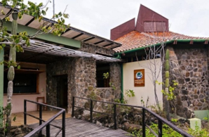
AM: INTERPRETATION CENTER
Located in the outskirts of Puerto Baquerizo, this center is dedicated to the history of human presence in the Galapagos. Since the times of the early Spanish explorers to the present times, including illustrious visitors such as Charles Darwin, this permanent exhibition will take you through the dangers and struggles of the first settlers trying to survive the harsh Galapagos environment.

Transfer to the airport and flight back to Ecuador mainland.

Accomodation: | *****
Included meals: | Breakfast

