GALAPAGOS ISLANDS
GALAXY DIVER -ITINERARY C
5 DAYS AND 4 NIGHTS
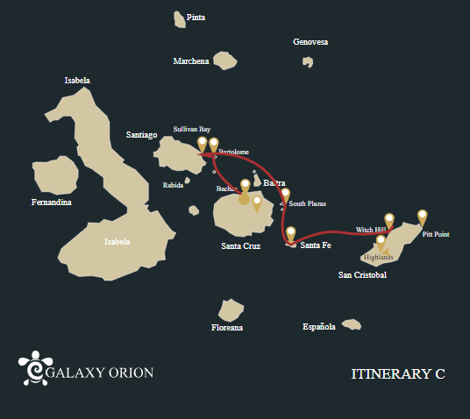

Itinerary C-5 days
Day 1 | AM: Baltra airport  PM: Bachas beach
Day 2 | AM: Bartolome: Bartolome  PM: Santtiago: Sullivan Bay
Day 3 | AM: Plazas: South Plazas  PM: Santa Fe: Santa Fe
Day 4 | AM: San Cristobal: Witch Hill  PM: San Cristobal: Pitt Point
Day 5 | AM: San Cristobal: Highlands  PM: San Cristobal Airport

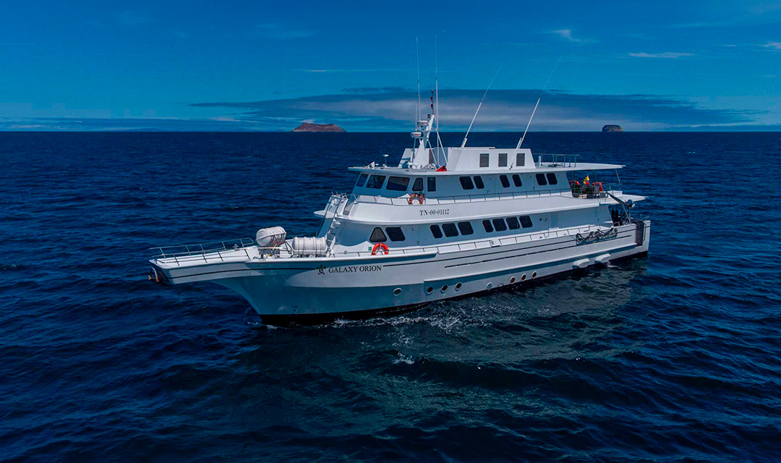

DAY 01: GALAXY ORION: BALTRA AIRPORT AND BACHAS BEACH
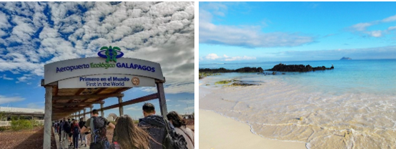
AM: ARRIVAL AT BALTRA AIRPORT
Your voyage to the captivating Galapagos Islands commences! Upon your arrival at Baltra Airport, you'll be greeted by our National Park-certified naturalist guide, ready to introduce you to the unique wonders of this pristine archipelago.

PM: BACHAS
Bachas, named after the mispronounced "barges" left by the Americans during WWII, begins your final day. At low tide, the iron skeletons of the barges can still be spotted buried in the white sand. This spot is one of the most crucial sea turtle nesting grounds in the Galapagos islands from November to May. Several small saltwater lagoons are often home to flamingoes, herons, and other aquatic birds.

Accomodation: | M/Y Galaxy Orion
Included meals: | Lunch or Box lunch, Dinner

DAY 02: GALAXY ORION: BARTOLOME ISLAND AND SULLIVAN BAY
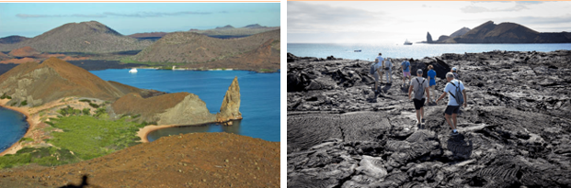
AM: BARTOLOME
Stand atop Bartolome Island for unparalleled views of the lunar-like landscape, punctuated by scattered volcanic cones, Pinnacle Rock, and the bay of Sullivan. Bartolome is a jewel in the Galapagos crown and home to a vibrant population of penguins.

Snorkeling Experience: A swim or snorkel from the beach opens up an underwater playground renowned in the Galapagos. Penguins, a multitude of fish, colorful invertebrates, sea lions, turtles, rays, and reef sharks make this snorkeling experience unforgettable.
PM: SULLIVAN BAY
Step back in time at Sullivan Bay, an open book to the volcanic birth of these islands. Traverse the well-preserved Pahoehoe lava field, studying its delicate, unique textures. The seemingly lifeless landscape gradually unveils a resilience of nature, with pioneer plants, lava lizards, and tiny birds emerging on careful observation. Keep your eyes on the shoreline for resident penguins, pelicans, and oystercatchers.

Snorkeling Experience: A dip in the water here starkly contrasts the barren land. The coral sand beach and the dinghy access point reveal a marine world with fish schools, Galapagos penguins, reef sharks, turtles, and rays.

Accomodation: | M/Y Galaxy Orion
Included meals: | Breakfast, Lunch, Dinner

DAY 03: GALAXY ORION: SOUTH PLAZAS AND SANTA FE ISLAND
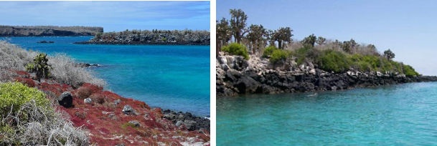
AM: SOUTH PLAZAS ISLAND
Begin your day with a visit to South Plazas Island, one of the smaller yet vibrant islands in the Galapagos. This island is renowned for its extraordinary flora, including towering cacti and the striking Sesuvium plant, which changes from green to bright red during the dry season. South Plazas is also home to a large colony of land iguanas, which are often seen lounging under the cacti or wandering around. The steep cliffs on the southern part of the island provide a haven for various seabirds, including swallow-tailed gulls and red-billed tropicbirds. Sea lions frequent the coastline and offers an excellent opportunity to observe their playful antics in the water.

PM: SANTA FE ISLAND
In the afternoon, set off to explore Santa Fe Island, known for its picturesque bay and turquoise waters, perfect for swimming and snorkeling. The island hosts a healthy population of the larger species of land iguanas unique to Santa Fe. Watch for these magnificent creatures as you walk through the giant prickly pear cactus forest. The island's calm, clear waters are ideal for spotting an array of marine life, including sea turtles, rays, and colorful schools of fish. Santa Fe also offers a chance to see the Galapagos hawk and various endemic finches.

This day offers a blend of terrestrial and marine exploration, showcasing the diverse landscapes and wildlife the Galapagos Islands are famous for.

Accomodation: | M/Y Galaxy Orion
Included meals: | Breakfast, Lunch, Dinner

DAY 04: GALAXY ORION: WITCH HILL AND PITT POINT
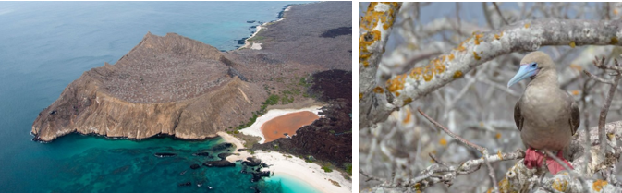
AM: CERRO BRUJO
Start your day at Cerro Brujo, a breathtaking white sand beach on San Cristobal Island's northern coast. This beach is one of the first sites visited by Charles Darwin. It's an exquisite spot for walking and enjoying the scenery, with its powdery white sand and turquoise waters. The area is home to a large sea lion colony, and the nearby lagoon often hosts several bird species, including pelicans and blue-footed boobies. The clear waters also make it an ideal spot for snorkeling, where you can encounter rich marine life.

Beach and Snorkeling Experience: Stroll along the white sands of Cerro Brujo, enjoy close encounters with sea lions, and explore the vibrant underwater world.

PM: PUNTA PITT
In the afternoon, head to Punta Pitt, located on the eastern end of San Cristobal Island. This unique site is the only place in the Galapagos where you can see all three species of boobies and two species of frigate birds. The trail here offers a challenging hike up a steep path but rewards with stunning views of the coastline. The beach area is also a great spot for snorkeling and swimming, offering a chance to see various marine life.

Hiking and Wildlife Observation: Explore the rugged terrain of Punta Pitt and witness the diverse birdlife, including all three booby species and frigate birds.

Accomodation: | M/Y Galaxy Orion
Included meals: | Breakfast, Lunch, Dinner

DAY 05: GALAXY ORION: HIGHLANDS OF SAN CRISTOBAL-FAREWALL GALAPAGOS
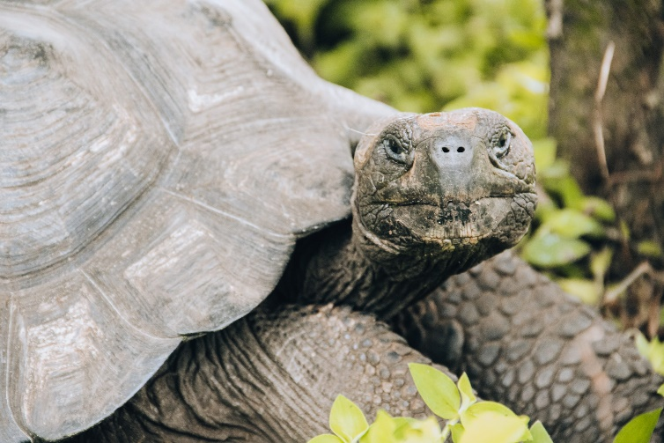
AM: SAN CRISTOBAL HIGHLANDS
Your day begins with a journey to the highlands of San Cristobal Island, offering a different perspective of the Galapagos' unique ecosystem. This lush and verdant area contrasts sharply with the coastal zones. The highlands are home to a variety of bird species, giant tortoises in their natural habitat, and a rich array of plant life, including endemic trees and ferns. You'll have the opportunity to walk along paths that meander through this lush landscape, offering a chance to observe the giant tortoises up close and personal. The highlands also provide panoramic views of the island, showcasing its diverse topography.

Transfer to San Cristobal airport for yoru flight to Ecuador mainland.

Accomodation: | *****
Included meals: | Breakfast

