GALAPAGOS ISLANDS
GALAXY YACHT-ITINERARY A
5 DAYS AND 4 NIGHTS
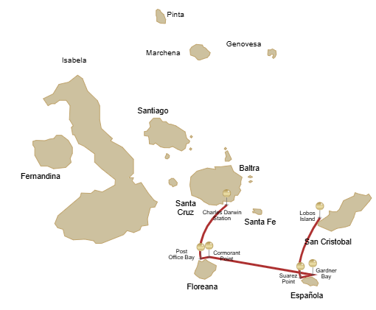

Itinerary A- 5 days
Day 1 | AM: San Cristobal airport  PM: San Cristobal: Lobos Island
Day 2 | AM: Española: Punta Suarez  PM: Española: Gardner Bay
Day 3 | AM: Floreana: Cormorant Point  PM: Floreana: Post Office Bay
Day 4 | AM: Charles Darwin Station

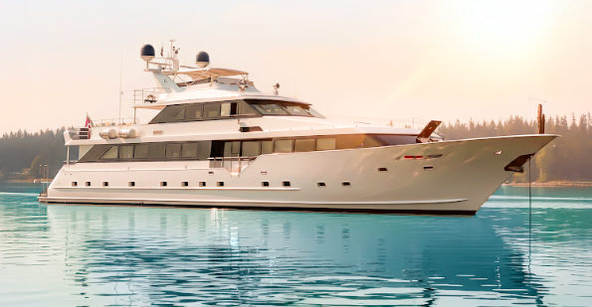

DAY 01: STELLA YACHT: SAN CRISTOBAL AIRPORT AND LOBOS ISLAND
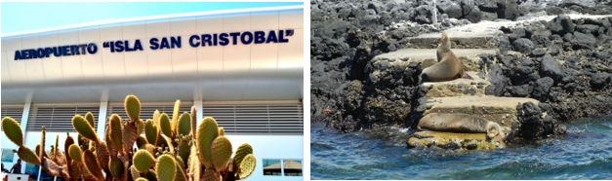
AM: SAN CRISTOBAL AIRPORT
Unfurl the sails of adventure and embark on an unforgettable journey to the Galapagos Islands. You'll arrive at San Cristobal Airport, where a seasoned naturalist guide, the custodian of this ecological gem, will greet you. Feel the flutter of anticipation as your exploration of this astonishing world heritage site commences.

PM: LOBOS ISLAND
Venture to Lobos Island, a tranquil islet secluded from San Cristobal by a slim channel. This nature's cradle, amidst a serene bay, is the playground for sea lion pups frolicking in tidal pools. The island might be modest in size, but it bursts with life, particularly with "lobos marinos" or sea lions. As you step ashore, welcoming committees of sea lions would greet you, only to be outraged by the male frigatebirds inland, presenting their inflamed red balloons amidst the verdant foliage. Stay vigilant for the blue-footed boobies nesting on the trails, ready to treat you to a display of their whimsical
courtship dance

Accomodation: | M/Y Galaxy Stella
Included meals: | Lunch or Box lunch, Dinner

DAY 02: STELLA YACHT: SUAREZ POINT AND GARDNER BAY
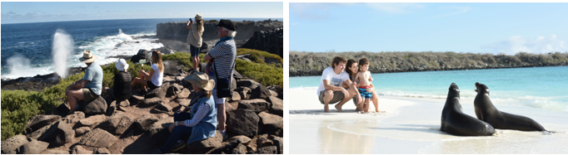

AM: SUAREZ POINT
This rocky trail is one the most amazing nature walks you can do in the Galapagos islands.
From the moment you set foot on the island and all the way along the trail the amount and diversity of fauna is truly amazing. Sea lions and marine iguanas will be the first ones welcoming us, followed by large colonies of sea birds, including Nazca and Blue-footed boobies, gulls and tropicbirds. At the end of the trail we will visit a colony of waved albatross (April to January), the largest bird in the islands and one of the most interesting because of its powerful flight

and elaborate courtship. Waved albatross only nest at Española, so this is the only place where you will see them at close range.

AM: GARDNER BAY
Gardner beach is undoubtedly one of the most beautiful and interesting beaches to visit in the Galapagos. It's fine coral sand and turquoise water give it a totally tropical appearance, which contrasts with the presence of sea lions basking in the beach. You will have the opportunity to walk along the beach and learn about the biology of sea lions and other endemic species, such as the Española mockingbird, marine iguanas and Galapagos hawks.

Snorkel: There are several great snorkeling places at Gardner bay. It is a fantastic site to swim with sea lions, reef sharks, rays and many species of fish, including; Angelfish, Parrotfish, Damselfish, Surgeonfish and many others.

Accomodation: | M/Y Galaxy Stella
Included meals: | Breakfast, Lunch, Dinner

DAY 03: STELLA YACHT: CORMORANT POINT AND POST OFFICE BAY

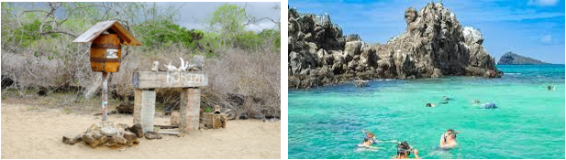

AM: POST OFFICE BAY
Begin your day by stepping into the footprints of the past at Post Office Bay, located on the enigmatic Floreana Island. This locale is imbued with tales from the late 1920s and '30s involving German settlers, a baroness, unsolved mysteries, and captivating intrigue. The bay was a historic anchoring point for whalers, who journeyed to the highlands for freshwater and tortoises. A mail system over two centuries old was established as a hub for visiting vessels centered around a barrel near the beach. This system endures today, offering a unique opportunity to send postcards from this remote part of the world. Apart from its rich history, Post Office Bay presents natural attractions such as a scenic beach, a lava tunnel, and sea tours that can unveil sea lions, green sea turtles, shorebirds, small sharks, and, if luck permits, Galapagos penguins.

Snorkeling Experience: Delve beneath the waves right from the beach, opening up a mesmerizing world of sea turtles, rays, and a diverse plethora of fish. Keep your fingers crossed for a special appearance by the elusive Galapagos penguin.

PM: CORMORANT POINT / DEVIL'S CROWN
Shift your expedition northwards to Punta Cormorant, renowned for its expansive coastal lagoon teeming with American flamingos, white-cheeked pintails, black-necked stilts, and other shorebirds. This natural haven also features a pristine white sand beach, a crucial nesting ground for green sea turtles, and a newly established breeding ground for blue-footed boobies near the trail. Amidst this vibrant wildlife, also take the opportunity to admire the island's unique flora.

Snorkeling Experience: At Devil's Crown, an eroded little volcano adjacent to Floreana Island, dive into what many consider one of the best snorkeling sites in the entire Galapagos. The Crown's currents funnel plankton, attracting a spectacular congregation of marine life, including snapper, Creole fish, parrot fish, Angelfish, reef sharks, sea turtles, and rays.

Accomodation: | M/Y Galaxy Stella
Included meals: | Breakfast, Lunch, Dinner

DAY 04: STELLA YACHT: CHARLES DARWIN STATION-FAREWALL GALAPAGOS

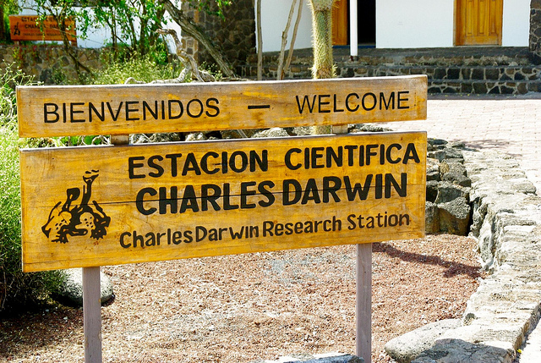

AM: CHARLES DARWIN STATION
Start your day with a profound encounter at the Charles Darwin Station, a dedicated non-profit working hand-in-hand with the Galapagos National Park to safeguard the archipelago's unique biodiversity. This visit provides insights into the collaborative efforts of these institutions to shield native species and combat the invasive ones threatening the delicate balance of the Galapagos ecosystem. One of their emblematic endeavors includes the captive breeding giant tortoises, an integral part of the conservation strategy. Amidst the educational venture, enjoy the setting of an outdoor native dry forest adorned with towering cacti and a rich array of fascinating endemic flora. This is an ideal spot to discover various endemic Darwin finches, as well as vivacious flycatchers and melodious mockingbirds.
Transfer to Baltra airpot and flight back to Ecuador mainland.

Accomodation: | *****
Included meals: | Breakfast

