GALAPAGOS ISLANDS
GALAXY YACHT-ITINERARY B
8 DAYS AND 7 NIGHTS
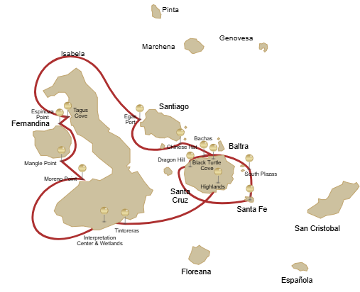
Itinerary B- 6 days
Day 1 | AM: Baltra: Baltra Airport  PM: Santa Cruz: Highlands
Day 2 | AM: Isabela: Tintoreras  PM: Isabela: Wetlands and Interpretation Center
Day 3 | AM: Isabela: Moreno Point  PM: Fernandina: Mangle Point
Day 4 | AM: Fernandina: Espinoza Point  PM: Isabela: Tagus Cove
Day 5 | AM: Santiago: Buccaneer Cove  PM: Santiago: Egas Port
Day 6 | AM: Bartolome: Bartolome  PM: Santiago: Sullivan Bay
Day 7 | AM: Chinese Hat: Chinese Hat  PM: Dragon Hill
Day 8 | AM: Black Turtle Cove

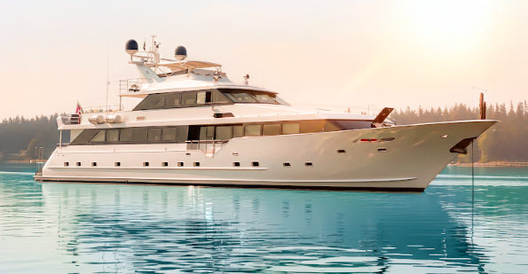

DAY 01: STELLA YACHT: BALTRA AIRPORT AND HIGHLANDS

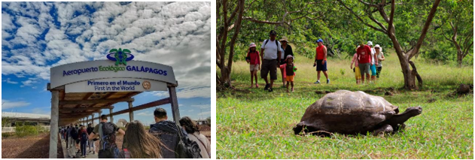

AM: BALTRA AIRPORT
Departure to the Galapagos Islands, arrival at Baltra airport, where our naturalist guide of the NationalPark will be waiting for you.

PM: HIGHLANDS OF SANTA CRUZ
A bus will take you to the highlands stopping along the way at one of the reserves to visit the lush highland forests where you will look for Galapagos Giant tortoises in their natural environment. This is the best place in the Galapagos to see these gentle giants (reaching over 300 kg / 600 pounds!) casually grazing and resting in freshwater ponds. This is also home for a great diversity of birds rarely found at the lowlands, including finches (tree, woodpecker and vegetarian finches), flycatchers and several species of water birds. You will visit a lava tunnel (depend on the itinerary) and learn how these extraordinary formations were created by ancient volcanic eruptions

Accomodation: | M/Y Galaxy Stella
Included meals: | Lunch or Box lunch, Dinner

DAY 02: STELLA YACHT: TINTORERAS AND WETLANDS AND INTERPRETATION CENTER

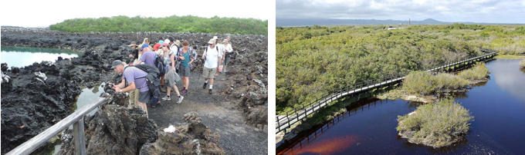

AM: TINTORERAS
Start your morning on Isabela Island, embarking on a unique adventure at Tintoreras, a cluster of small isles teeming with wildlife. Sail through crystal-clear waters and discover a vibrant underwater world inhabited by white-tipped sharks, colorful tropical fish, and starfish. The hike will take you through lunar landscapes and breathtaking views, where you’ll learn about volcanic geology and the endemic flora and fauna.

Snorkeling: Dive into the marvelous marine world of Isabela. Swim alongside sea turtles, manta rays, and, if you’re lucky, Galapagos penguins.

PM: ISABELA ISLAND WETLANDS & INTERPRETATION CENTER
In the afternoon, explore the wetlands of Isabela Island, a vital ecosystem for the biodiversity of the Galapagos. These trails take you through mangroves, saline lagoons, and beaches, where you can spot flamingos, blue-billed ducks, and other aquatic birds. Conclude the day at the Interpretation Center, discovering the natural and human history of the islands, their conservation, and the ongoing efforts to protect this World Heritage Site.

Accomodation: | M/Y Galaxy Stella
Included meals: | Breakfast, Lunch, Dinner

DAY 03: GALAXY YACHT: MORENO POINT AND MANGLE POINT
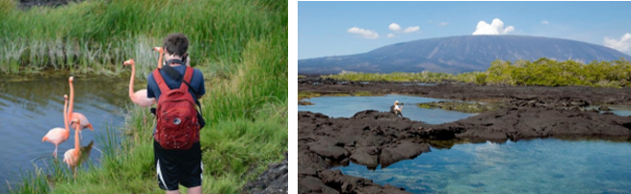

AM: MORENO POINT
Moreno Point is a magical place with extensive lava fields which look lifeless at first sight. Once inland, scattered brackish lagoons form oasis of life where you can find flamingoes, gallinules, ducks and herons. Along the shore we will look for penguins, marine iguanas, flightless cormorants, blue-footed boobies, sea lions, oystercatchers and other shore birds.

Snorkel: We will snorkel to see sea turtles, cormorants and many species of fish. Look carefully in the
long seaweeds and you might find a sea horse.

PM: MANGLE POINT
Begin your day at Mangle Point on the pristine Fernandina Island, one of the Galapagos's most untouched and ecologically pure islands. This location offers a spectacular mangrove ecosystem, a haven for wildlife. As your boat gently navigates through the clear waters, observe the intricate mangrove roots where marine turtles and rays often hide. The calm and shallow waters make this an ideal spot for snorkeling, offering a chance to swim alongside sea turtles, various species of rays, and abundant tropical fish. Mangle Point presents a unique opportunity to witness the symbiosis between the mangrove forests and the marine environment, offering a serene and intimate experience with nature.

Snorkeling Experience: Immerse yourself in the tranquil waters of Mangle Point—experience close encounters with the diverse marine life that thrives among the mangroves and coral reefs.

Accomodation: | M/Y Galaxy Stella
Included meals: | Breakfast, Lunch, Dinner

DAY 04: GALAXY YACHT: ESPINOZA POINT AND TAGUS COVE
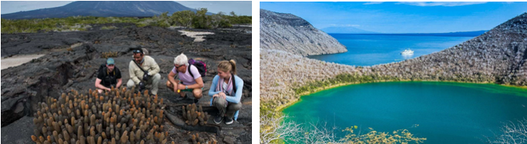
AM: ESPINOZA POINT
Espinoza Point is a National Park gem located at the base of an imposing volcano (the most active in the Galapagos islands). Upon landing, be greeted by hundreds of marine iguanas in the largest colony for the species. Also present are sea lions, flightless cormorants, herons, pelicans, oystercatchers, sea turtles, shorebirds, and more. Look to the mangroves where Galapagos hawks often perch, on the lookout for prey.

Snorkeling Experience: Immerse yourself in the nutrient-rich waters around Espinoza Point, brimming with a plethora of fish and sea turtles. Witness marine iguanas feeding underwater amidst a cornucopia of seaweeds.

PM: TAGUS COVE
Tagus Cove, a location visited by Charles Darwin during his Galapagos exploration, offers a dry Palo Santo forest where Darwin finches and mockingbirds reside. Take in the marvelous views of Darwin's Lake and the grand volcanos of northern Isabela. A boat tour along the coast will reveal penguins, cormorants, marine iguanas, and the Galapagos martin, an endangered endemic species.

Snorkeling Experience: Dive into the nutrient-rich waters around Tagus Cove, where many sea turtles, a great diversity of fish, and penguins await, feasting on large schools of anchovies. Cormorants are commonly spotted underwater as they chase fish through the reef.

Accomodation: | M/Y Galaxy Stella
Included meals: | Breakfast, Lunch, Dinner

DAY 05: GALAXY YACHT: EGAS PORT AND CHINESE HAT
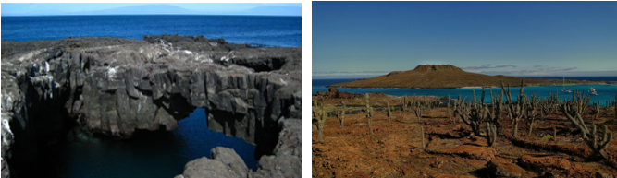
AM: EGAS PORT
Despite its misleading name, there isn't a traditional "port" at Puerto Egas, yet some remnants of past attempts to colonize the island during the 1960s can still be seen. The trail here follows the coastline, an area rich in wildlife. You will see marine iguanas basking in the sun everywhere you turn, along with Galapagos sea lions, herons, oystercatchers, and many shorebirds. Towards the trail’s end, you'll encounter "the grottos,” home to a small colony of the elusive endemic Galapagos fur seal, much more challenging to spot than its cousin. As recently as 2019, land iguanas were reintroduced to the area, so keep an eye out for these impressive reptiles, which had been extinct from Santiago for over a century.

Snorkeling Experience: A snorkeling session from the beach will lead you to an area of rocky bottoms, excellent for observing fish, turtles, and reef sharks. Sea lions often frequent this area and are typically open to interacting with divers.

PM: CHINESE HAT
Welcome to the perfectly symmetrical volcanic cone of Chinese Hat! Separated from Santiago by a slender channel, this idyllic islet is framed by turquoise waters, coral sand beaches, and dark lava rocks – an unexpected haven for penguins. A shore trail brings you up close to a small colony of sea lions.

Snorkeling Experience: Experience a world of vividly colored fish, sleek reef sharks, and perhaps a swift penguin chasing after a school of anchovies. It's a mesmerizing underwater spectacle you want to take advantage of.

Accomodation: | M/Y Galaxy Stella
Included meals: | Breakfast, Lunch, Dinner

DAY 06: GALAXY YACHT: BLACK TURTLE COVE-FAREWALL GALAPAGOS
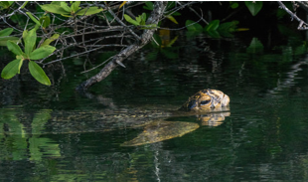
AM: BLACK TURTLE COVE
Black Turtle Cove gets its name from the abundance of green sea turtles, locally known as: “tortugas negras”. There is no landing here so you will be doing a boat tour on the dinghies, exploring shallow channels and small coves surrounded by beautiful mangrove forests. Reef sharks, sea turtles and several species of rays inhabit this beautiful area which is considered an important mating area for turtles and a nursery for several species of sharks. Herons, pelicans and boobies are also common here as they pray in schools of anchovies.

At the end of the visit you will be transferred to Baltra airport for your flight back to Ecuador mainland.

Accomodation: | *****
Included meals: | Breakfast

