GALAPAGOS ISLANDS
GALAXY YACHT-ITINERARY C
6 DAYS AND 5 NIGHTS
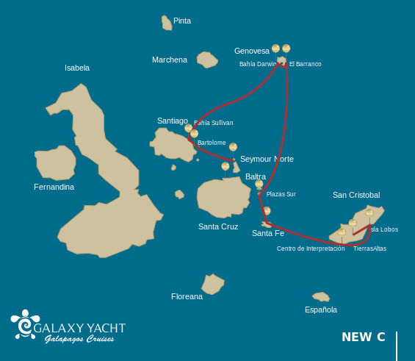
Itinerary C- 6 days
Day 1 | AM: Baltra: Baltra airport  PM: North Seymour: Seymour
Day 2 | AM: Bartolome: Bartolome  PM: Santiago: Sullivan Bay
Day 3 | AM: Genovesa: Darwin Bay  PM: Genovesa: El Barranco
Day 4 | AM: Plazas: South Plazas  PM: Santa Fe: Santa Fe
Day 5 | AM: San Cristobal: Interpretation Center  PM: San Cristobal: Lobos Islands
Day 6 | AM: San Cristobal: Highlands  PM: San Cristobal: Airport

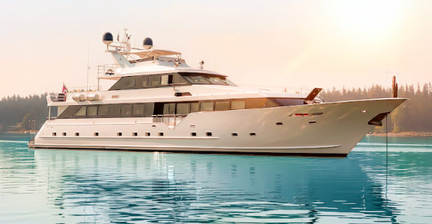

DAY 01: GALAXY YACHT: BALTRA AIRPORT AND NORTH SEYMOUR
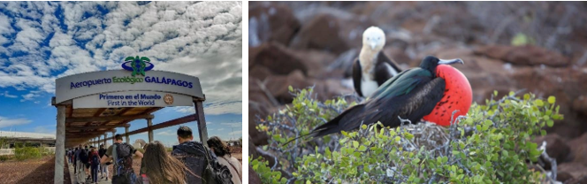

AM: BALTRA AIRPORT
Departure to the Galapagos Islands, arrival at Baltra airport, where our naturalist guide of the NationalPark will be waiting for you.

PM: SEYMOUR
This island is home for large colonies of both magnificent and great frigate birds and you can see them displaying their red balloons to attract a female. Blue-footed boobies’ nest in the ground and perform their famous dance in the open areas, while swallow-tailed gulls perch on the cliff edges. Land iguanas are common inland while their marine cousins bask in the rocks by the sea, close to sea lions, which often like to body surf in the waves.

Snorkel: This place is a really great snorkeling location, as it has tremendous diversity and amount of fish, but also sea lions, sharks, eels, turtles, rays and many more.

Accomodation: | M/Y Galaxy Stella
Included meals: | Lunch or Box lunch, Dinner

DAY 02: GALAXY YACHT: BARTOLOME AND SULLIVAN BAY

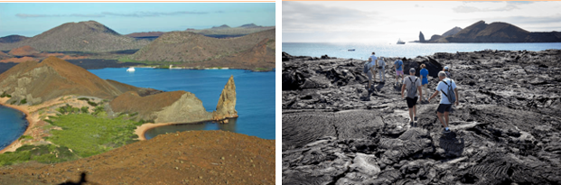

AM: BARTOLOME
Stand atop Bartolome Island for unparalleled views of the lunar-like landscape, punctuated by scattered volcanic cones, Pinnacle Rock, and the bay of Sullivan. Bartolome is a jewel in the Galapagos crown and home to a vibrant population of penguins.

Snorkeling Experience: A swim or snorkel from the beach opens up an underwater playground renowned in the Galapagos. Penguins, a multitude of fish, colorful invertebrates, sea lions, turtles, rays, and reef sharks make this snorkeling experience unforgettable.
PM: SULLIVAN BAY
Step back in time at Sullivan Bay, an open book to the volcanic birth of these islands. Traverse the well-preserved Pahoehoe lava field, studying its delicate, unique textures. The seemingly lifeless landscape gradually unveils a resilience of nature, with pioneer plants, lava lizards, and tiny birds emerging on careful observation. Keep your eyes on the shoreline for resident penguins, pelicans, and oystercatchers.

Snorkeling Experience: A dip in the water here starkly contrasts the barren land. The coral sand beach and the dinghy access point reveal a marine world with fish schools, Galapagos penguins, reef sharks, turtles, and rays.

Accomodation: | M/Y Galaxy Stella
Included meals: | Breakfast, Lunch, Dinner

DAY 03: GALAXY YACHT: DARWIN BAY AND EL BARRANCO

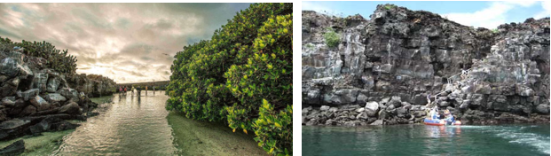

AM: DARWIN BAY
Genovesa is a favorite island for birdwatchers as it is home for very large colonies of seabirds. From the minute you set foot at the beach you will be amazed by the noise of hundreds of boobies, gulls and frigatebirds flying over your heads, perched in the bushes or nesting on the sandy terrain. The trail is an ultimate wildlife experience as there are animals everywhere; sea lions and marine iguanas near the sea; night herons, lava & swallow tailed gulls, Darwin finches, Galapagos doves, mockingbirds and many more species inland.

Snorkel: The bay offers several places to snorkel; from deep waters along the cliffs across the bay, to shallow waters by the beach. In either case, there are many fish to see and great chances of seeing sharks, rays and sea lions.

PM: EL BARRANCO
El Barranco is located in the southern part of Darwin Bay at Genovesa Island. The cliffs facing the sea are made of very fragile fractured lava, making it the ideal place for storm petrels to build their colonies, which attracts an important population of short-eared owls preying on the nesting birds. Red footed and Nazca boobies are abundant along the trail. At the base of the cliffs you can see Galapagos fur seals resting in shaded areas, as well as several species of seabirds.

Snorkel: You can snorkel along the cliffs where there are many fish and great chances of seeing sharks, rays and sea lions.

Accomodation: | M/Y Galaxy Stella
Included meals: | Breakfast, Lunch, Dinner

DAY 04: GALAXY YACHT: SOUTH PLAZAS AND SANTA FE

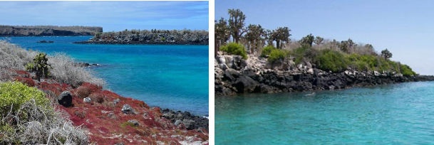

AM: SOUTH PLAZAS ISLAND
Begin your day with a visit to South Plazas Island, one of the smaller yet vibrant islands in the Galapagos. This island is renowned for its extraordinary flora, including towering cacti and the striking Sesuvium plant, which changes from green to bright red during the dry season. South Plazas is also home to a large colony of land iguanas, which are often seen lounging under the cacti or wandering around. The steep cliffs on the southern part of the island provide a haven for various seabirds, including swallow-tailed gulls and red-billed tropicbirds. Sea lions frequent the coastline and offers an excellent opportunity to observe their playful antics in the water.

PM: SANTA FE ISLAND
In the afternoon, set off to explore Santa Fe Island, known for its picturesque bay and turquoise waters, perfect for swimming and snorkeling. The island hosts a healthy population of the larger species of land iguanas unique to Santa Fe. Watch for these magnificent creatures as you walk through the giant prickly pear cactus forest. The island's calm, clear waters are ideal for spotting an array of marine life, including sea turtles, rays, and colorful schools of fish. Santa Fe also offers a chance to see the Galapagos hawk and various endemic finches.

This day offers a blend of terrestrial and marine exploration, showcasing the diverse landscapes and wildlife the Galapagos Islands are famous for.

Accomodation: | M/Y Galaxy Stella
Included meals: | Breakfast, Lunch, Dinner

DAY 05: GALAXY YACHT: INTERPRETATION CENTER AND LOBOS ISLANDS

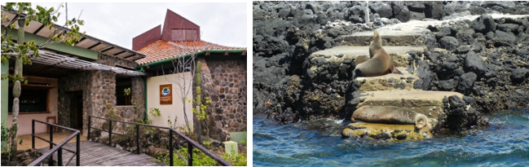
AM: INTERPRETATION CENTER
Located in the outskirts of Puerto Baquerizo, this center is dedicated to the history of human presence in the Galapagos. Since the times of the early Spanish explorers to the present times, including illustrious visitors such as Charles Darwin, this permanent exhibition will take you through the dangers and struggles of the first settlers trying to survive the harsh Galapagos environment.

PM: LOBOS ISLAND
Lobos island is a small islet separated from San Cristobal by a narrow channel, forming a sheltered bay where sea lion pups play in tidal pools. Despite its small size, the island is surprisingly packed with wildlife, especially with “lobos marinos”, the Spanish name for sea lions. Groups of sea lions will welcome you at the landing spot, but as you walk a few steps inland, male frigatebirds displaying their inflated red balloons will be perched on the bushes and trees. A small colony of blue footed boobies, which often nest right on the trail, will give you the opportunity to observe their famous courtship dance.

Snorkel: This is a great snorkeling location as the water are usually calm and the sea lions often play with divers to show off their swimming skills. Sea turtles and rays are often seen resting in the sandy bottoms.

Accomodation: | M/Y Galaxy Stella
Included meals: | Breakfast, Lunch, Dinner

DAY 06: GALAXY YACHT: HIGHLANDS- FAREWALL GALAPAGOS

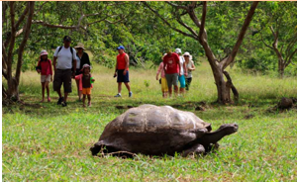
AM: HIGHLANDS
Either if you do this visit starting from Baltra or from Puerto Ayora, a bus will take you to the highlands stopping along the way at one of the reserves to visit the lush highland forests where you will look for Galapagos Giant tortoises in their natural environment. This is the best place in the Galapagos to see these gentle giants (reaching over 300 kg / 600 pounds!) casually grazing and resting in freshwater ponds. This is also home for a great diversity of birds rarely found at the lowlands, including finches (tree, woodpecker and vegetarian finches), flycatchers and several species of water birds. You will visit a lava tunnel (depend on the itinerary) and learn how these extraordinary formations where created by ancient volcanic eruptions.

Accomodation: | *****
Included meals: | Breakfast

